View Server - User Guide
View Server - User Guide
- Introduction
- Web Client
- Searching
- Viewing
- Downloading
- Sample Service Requests
View Server - User Guide
- »
- View Server - User Guide

View Server - User Guide
This is the documentation for users of the View Server. The PDF format of this documentation for the latest version is located at user-guide. The operator documentation can be found at operator-guide.

View Server - Contents

Introduction
This is the User Guide of the View Server (VS). The intended readers are users of the web client shown below and external services provided by the View Server.
These provided external services are services for searching, viewing, and downloading of Earth Observation (EO) data. Service endpoints optimized for performance as well as for flexibility are provided alongside each other.
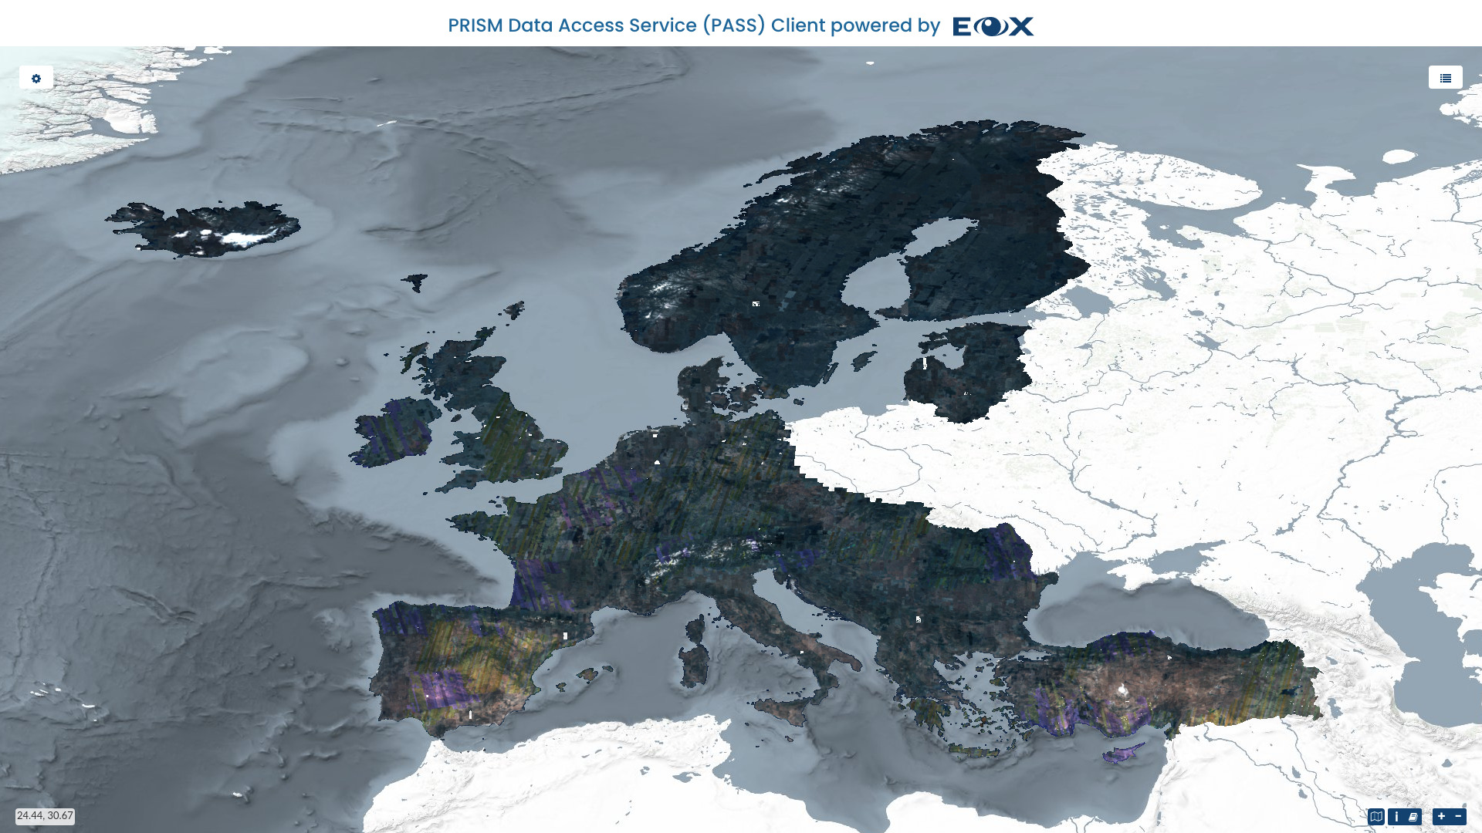
Figure 1 Web Client
Continue reading to understand the details of the provided Web Client.
Available production deployments of the VS referencing data from Copernicus Space Component Data Access (CSCDA) are on:
- VHR IMAGE 2018: https://sso.vhr18.pass.copernicus.eu
- Emergency https://sso.emg.pass.copernicus.eu
- Copernicus DEM Open https://sso.demf.pass.copernicus.eu
- Copernicus DEM Restricted https://sso.dem.pass.copernicus.eu
- Frontex Emergency https://sso.frtx-emg.pass.copernicus.eu
- SatCen Emergency https://sso.sace-emg.pass.copernicus.eu
- Csea Emergency https://sso.csea-emg.pass.copernicus.eu
- VHR IMAGE 2015 https://sso.vhr15.pass.copernicus.eu
- VHR1-2 Urban Atlas 2012 https://sso.ua2012.pass.copernicus.eu
- DWH_MG2_CORE_01 - Optical HR Pan EU Coverages (Image2012) https://sso.core12.pass.copernicus.eu
- DWH_MG2_CORE_02 - Optical HR Pan EU coverages (Image2006 and Image2009) https://sso.core09.pass.copernicus.eu
- VHR IMAGE 2021 https://sso.vhr21.pass.copernicus.eu

Authentication
Authentication/Authorization to the PASS production deployments is linked to the main authentication framework of CSCDA and both systems share login sessions, the user needs to log in just once.
Note that the used authentication system of CSCDA is based on SAML protocol, which at the moment of writing this text is not supported for authentication by modern GIS browsers (QGIS 3.x, ArcMap, ArcGIS Pro).

Web Client
The most comfortable way to exploit the functionalities of the View Server (VS) is via the built-in web client. This client is based on the open source eoxc library and provides an intuitively to use interactive graphical user interface running in the user’s web browser.

Minimum Required Resources
The default 2D version of the web client can be used with any modern browser including even mobile versions with some usability limitations.
In order to run the web client in 3D mode for example for the DEM collections, minimum hardware and software requirements are basically attached to WebGL (Web Graphics Library) resource requirements, as the 3D client software requires a browser that supports WebGL. The table below shows the minimum required versions of major web browsers that have support of WebGL 1.0. Support has been verified using the BrowserStack service. For a complete list of supported browser versions please refer to https://caniuse.com/webgl.
Mozilla Firefox | Google Chrome | Apple Safari | MS Edge
>= 4 | >= 8 | >= 5.1 | >= 12

Interactive Tutorial
When the web client is opened for the first time a short interactive tutorial starts as shown in Figure 2 below. It guides the user through the main features and elements.
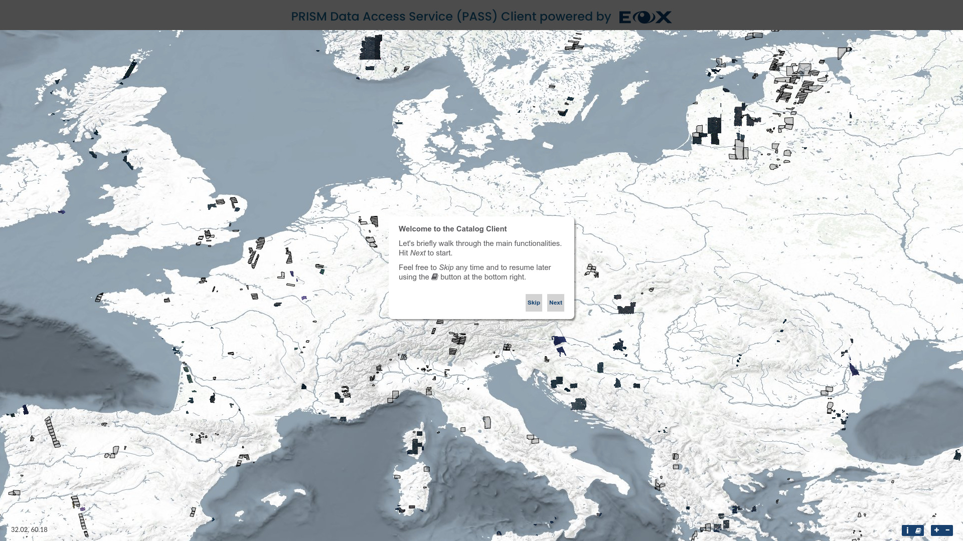
Figure 2 Web Client Tutorial - Start
The tutorial can be started again anytime by clicking the book icon in the bottom right of the window.
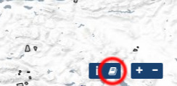
Figure 3 Web Client Tutorial Button

Map
The main map view is for visualization and interactively browsing through available satellite data. There are two modes or types of visualization, 2D and 3D. Users can switch between the two modes by clicking the 2D/3D switch button in the top center of the map.
Figure 4 3D/2D visualization switch button

3D View
3D mode launches a virtual three dimensional globe scene, provided with terrain data.
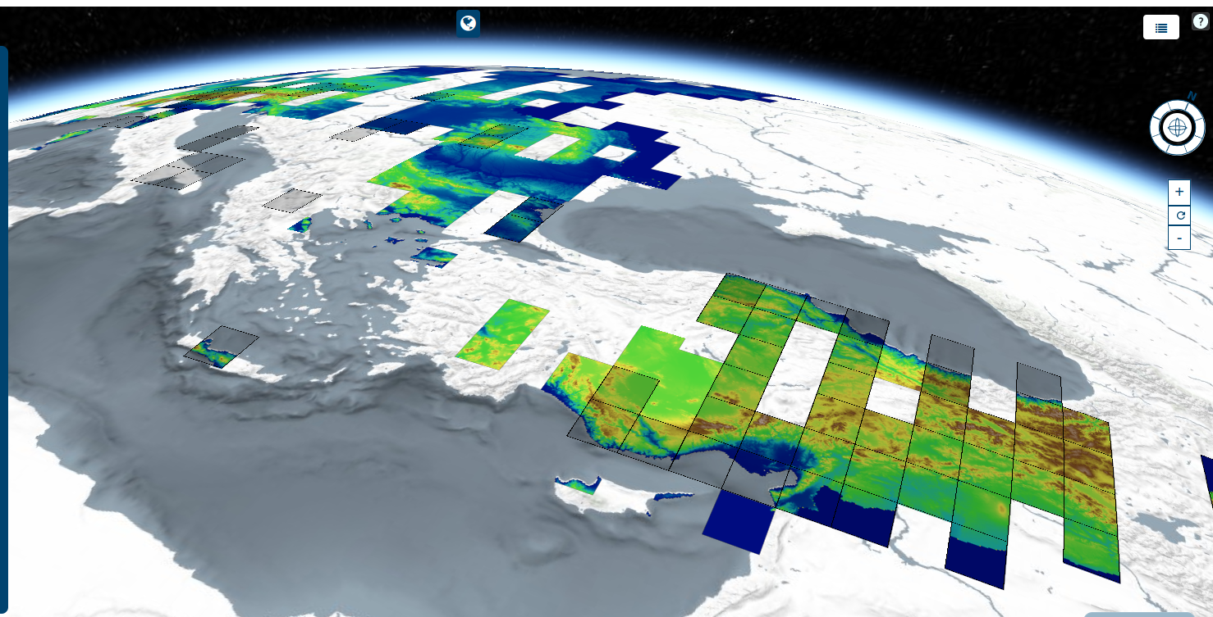
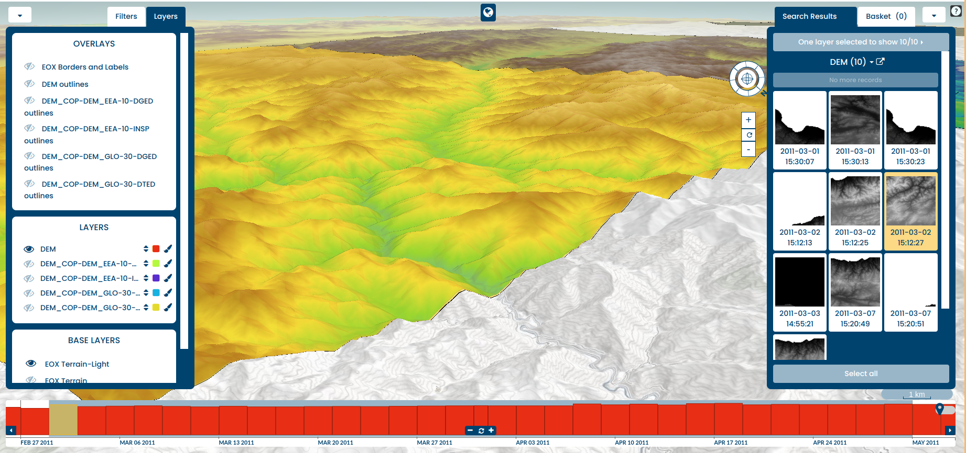
Figure 5 3D visualization
Navigating to the area of interest is done by:
- panning: left click + drag or one finger drag.
- zooming: mouse wheel scroll, double click, two finger pinch.
- rotating : Middle click + drag, or by pressing CTRL button + Left/Right click + drag.
in the upper right corner of the 3D map you can find the tutorial/help button. Pressing it will open a widget for displaying instructions for navigating the globe with the mouse.
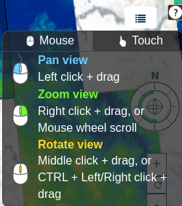
Figure 6 Web Client Tutorial - Map
Additionally, on the upper left side of the map (right to the left panel) there are navigation buttons to zoom in/out and a reset button to reset the position, and an interactive compass to aid the user to move and re-reorientate the view.
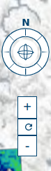
Figure 7 Web Client Tutorial - Map

2D View
In 2D navigating to the area of interest is done by:
- panning: left click + drag or one finger drag and
- zooming: mouse wheel scroll, double click, two finger pinch, or the plus and minus icons in the bottom right corner of the map.
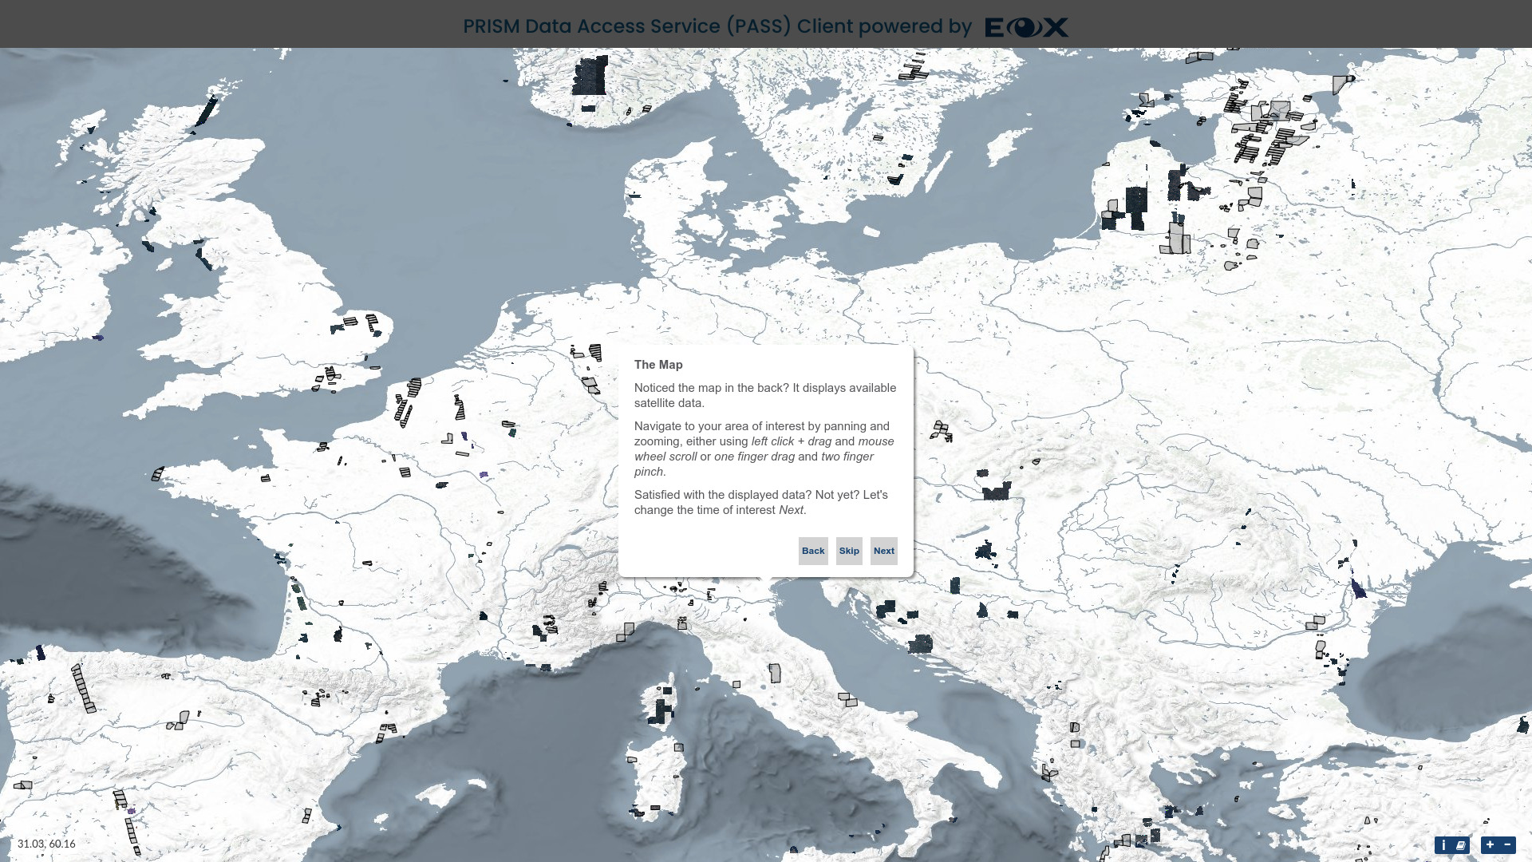
Figure 8 Web Client Tutorial - Map
While hovering over footprints on the map, the respective product(s) are highlighted in the map, timeslider, and the Search Results menu. The same behavior is applied vice versa while hovering over dot groups in the timeslider and individual items in the Search Results.
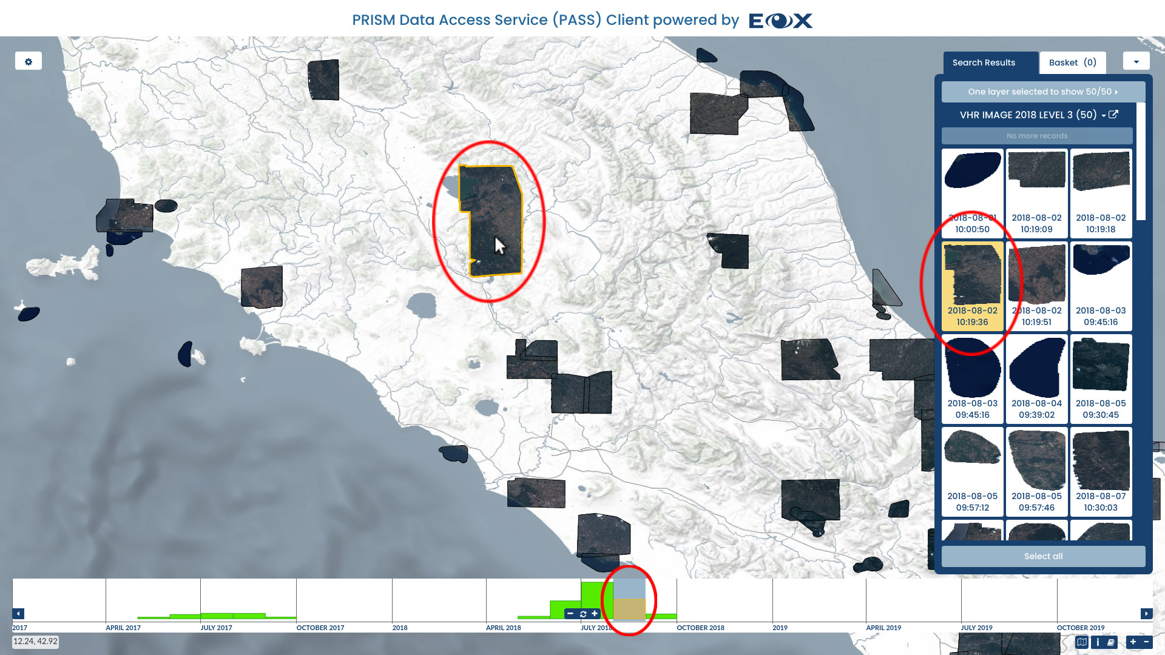
Figure 9 Web Client - 3-way highlighting
Clicking on a footprint in the map followed by clicking on the plus or minus button can be used to add or remove a product to or from the basket, holding the list of products selected for download (see Download below).
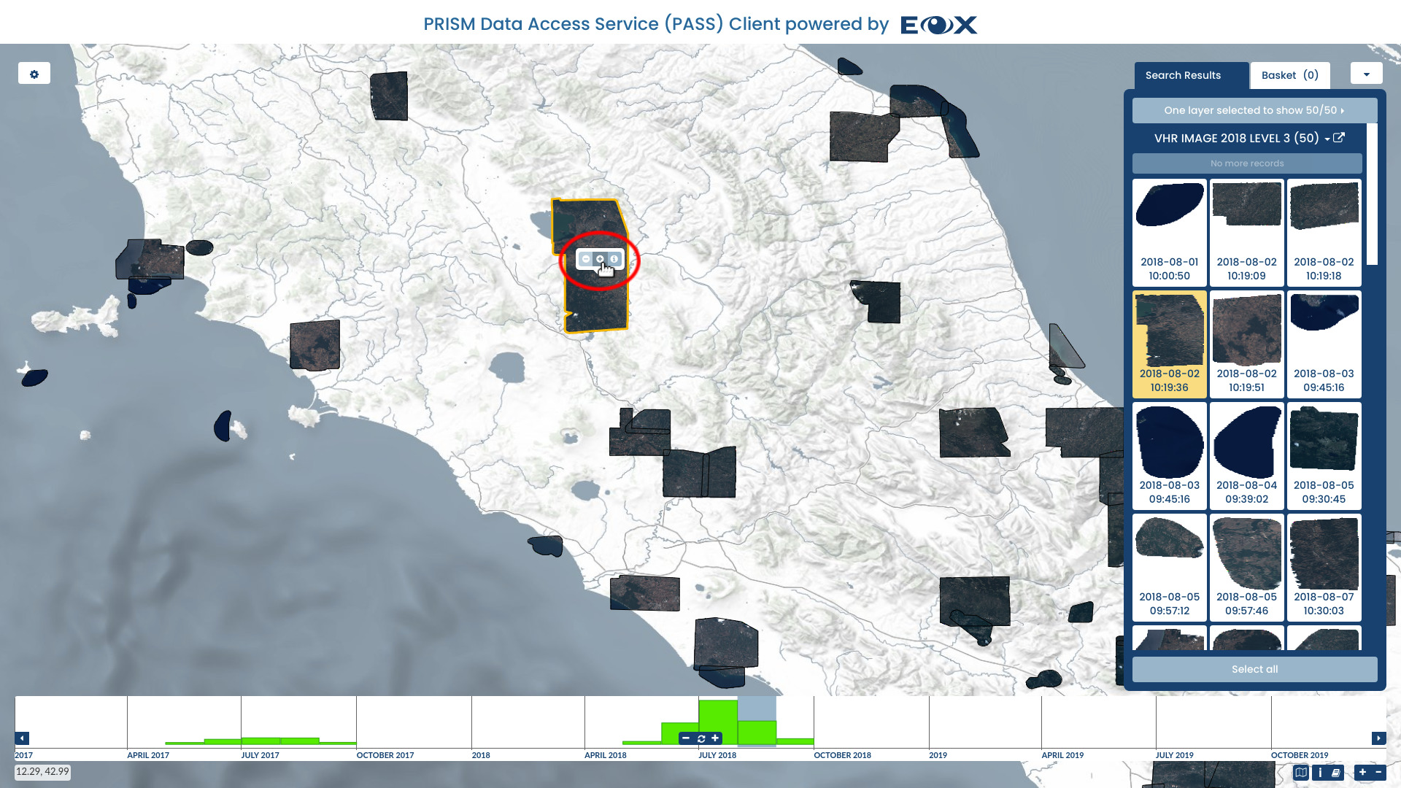
Figure 10 Web Client - Select on map
In the top most part of the map, there is a colored bar spanning the full width of the web client acting as loading indicator. It makes it easier to see if the loading of all requested map tiles is already finished or still in progress.
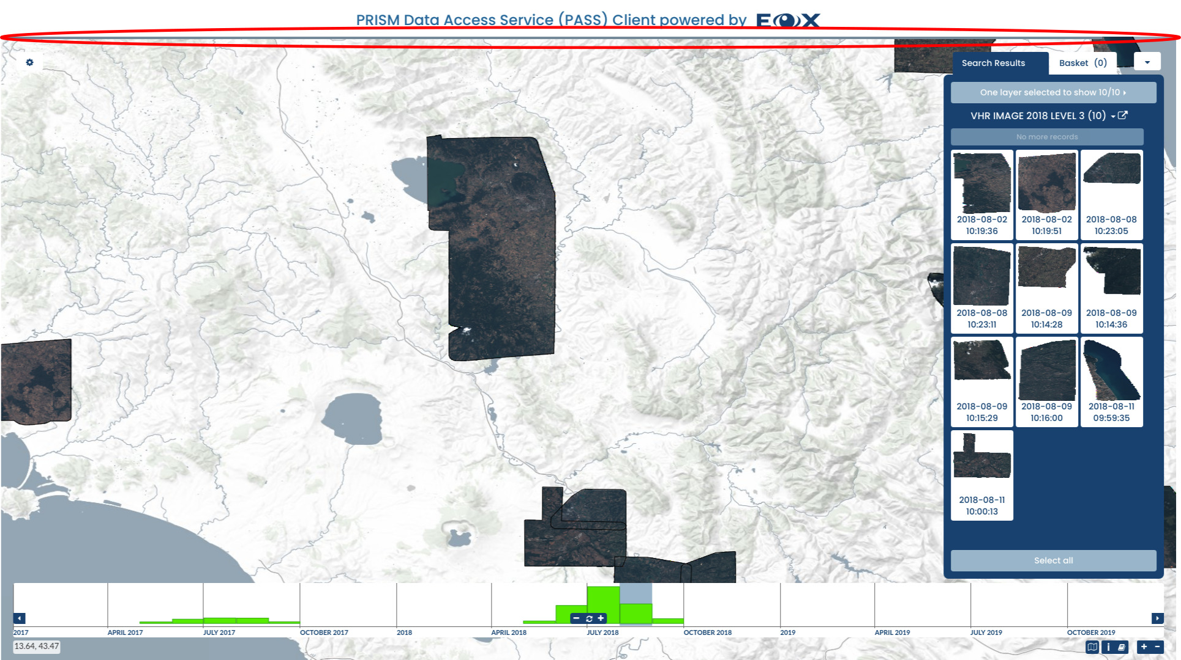
Figure 11 Web Client - Loading indicator
The geographic coordinates of the current cursor location can be seen as longitude, latitude pair in the bottom left corner of the map.
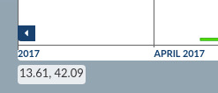
Figure 12 Web Client - Coordinates
Warning: Following feature is available only for collections where a flexible WMS or WMTS rendering is configured. If WMTS is used as default access services, the WMS service must be exposed on the same endpoint. This is default setup for VS cache service. Clicking on the landscape map icon in the bottom right of the map window shows a list of available layers. Clicking on one of the layers opens a new browser tab showing this layer as currently visible on the map by generating a WMS request copying the current map parameters (zoom, bounding box, selected time, styling, etc.) in a new tab or downloading the image.
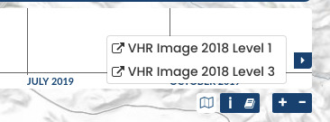
Figure 13 Web Client - Current view

Timeslider
The timeslider presents the distribution of products in time via a bar (see Figure 14) or an aggregated dots (see Figure 15) graph. The visualization mode used (bars or dots) is based on the total number of products available for the shown time interval.
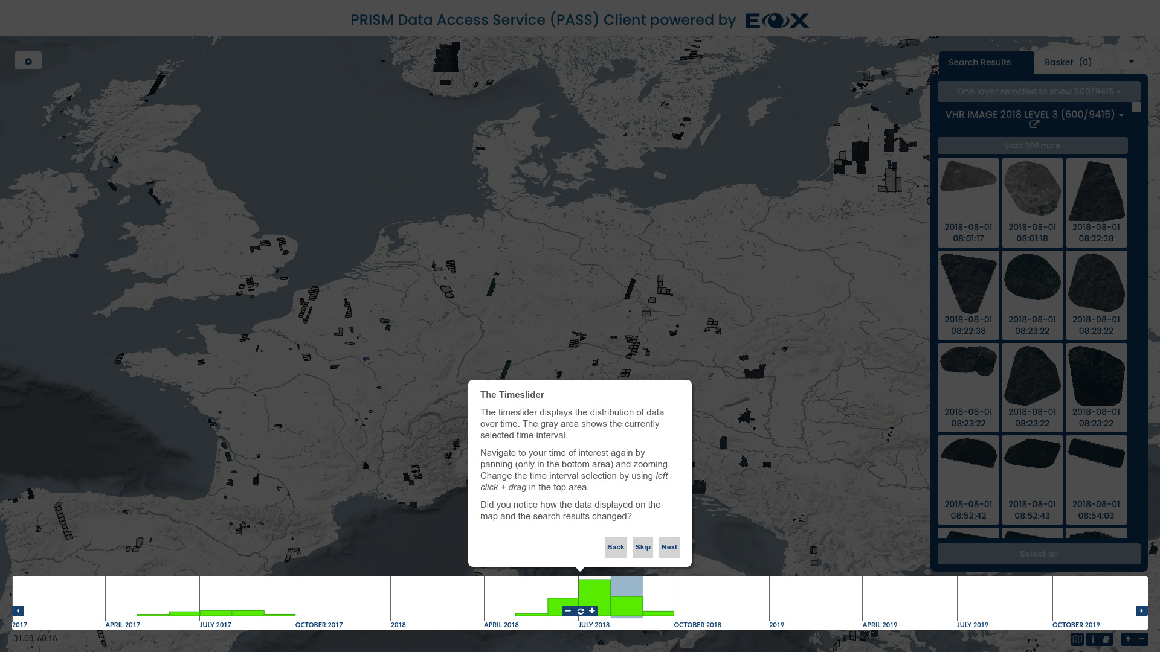
Figure 14 Web Client Tutorial - Timeslider
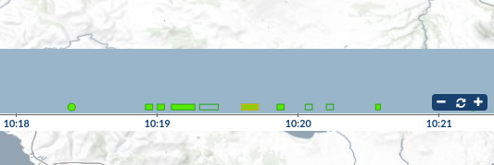
Figure 15 Web Client - Timeslider dots
The interactive timeslider can be used in the following ways:
- panning: left click + drag or one finger drag on the bottom area (below the horizontal line) or left and right arrow icons on the sides
- zooming: mouse wheel scroll, two finger pinch, or plus and minus icons in the middle
- reloading: spinner icon in the middle
- selecting a time interval: left click + drag or one finger drag in the upper area (above the horizontal line) or click on a histogram bucket
- showing the total number of available products in a histogram bucket: hover over the histogram bucket
- showing the footprints of all products, the first product id, and the total number of additional products in a dot group: hover over the dot group
- showing start and end of the current selection: left click + hold on selection rectangle
- zooming the map to a combined minimum bounding box of all products in a dot group: click on the dot group
There are currently two ways how timeslider works connected to spatial filters:
- Spatially un-aware: Always shows time distribution of all available products.
- Spatially aware: Takes currently set spatial filter (or current map view) in account when displaying histograms. That way, time distribution of products over a specific area can be evaluated.
In order to change between the modes, use the location switch in top right edge of the timeslider panel.
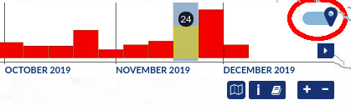
Figure 16 Web Client - Timeslider spatial toggle

Search Results
The panel in the right part of the map window has a tab showing the Search Results grouped by enabled layer(s). The search is defined by the currently visible geographic area or spatial filter, selected time interval, and additional filters if set. Items in the list are sorted as the catalog returns them which typically is from the oldest to the newest.
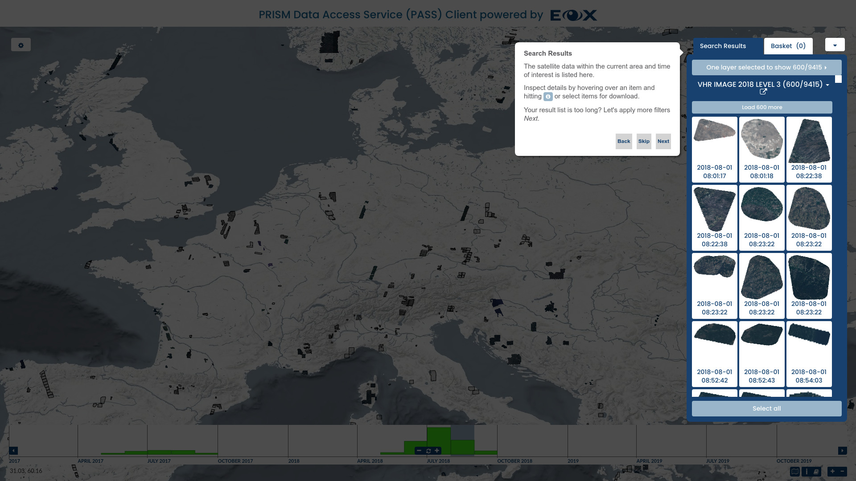
Figure 17 Web Client Tutorial - Search Results
Searching can be disabled and enabled again for each displayed layer individually by clicking on the large button labeled N layer(s) selected to show n/n and clicking on the corresponding layer entry (see Figure 18) or by clicking on the Search toggle (see Figure 19) if only a single layer is configured.
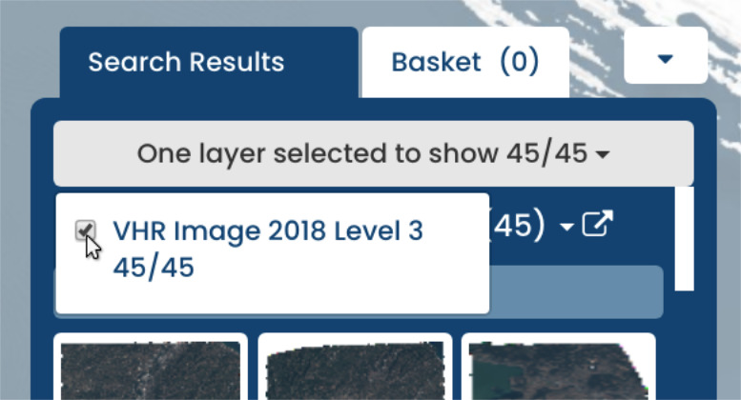
Figure 18 Web Client - Toggle search
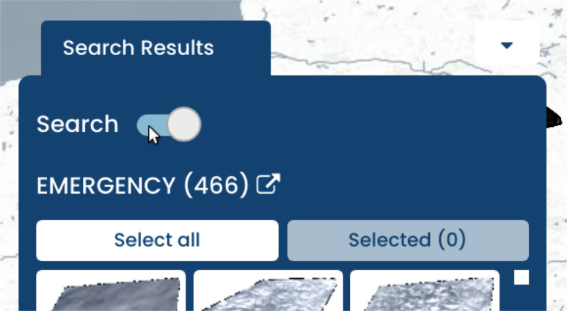
Figure 19 Web Client - Toggle search single layer
Metadata and alternative visualizations of individual products can be inspected by hovering over an item and hitting the info icon either in the search results (see Figure 20) or on the map (see Figure 21). That opens a new overlay panel showing details display (see Details Display below).
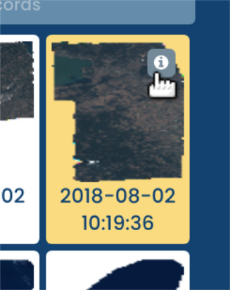
Figure 20 Web Client - Details button 1
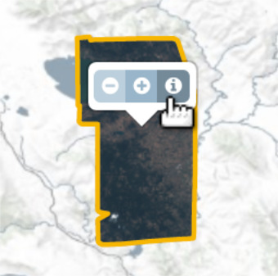
Figure 21 Web Client - Details button 2
By clicking on individual items, they can be inserted to or removed from the basket holding the list of items selected for download.
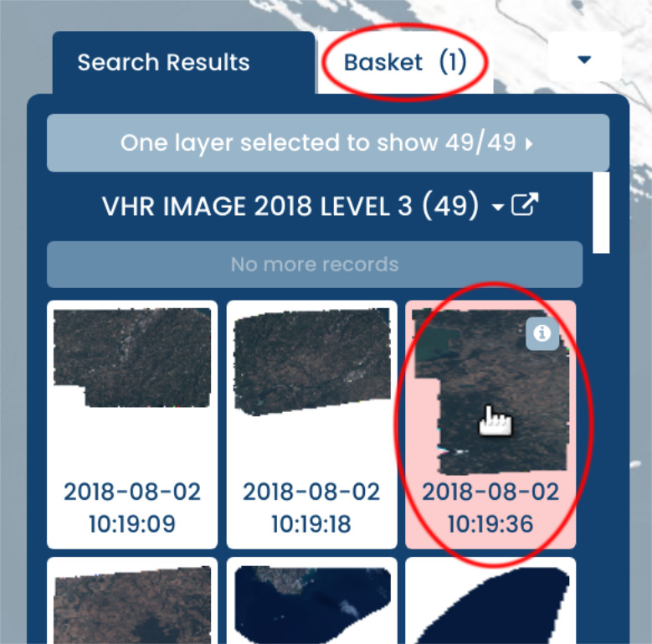
Figure 22 Web Client - Add item to basket
Searching from the web client is throttled for performance and only a limited number of items is shown from the first search. Additional items, if available, are shown by clicking the button labeled Load n more.
The Select all button adds all currently listed items to the basket.
The link button next to the layer name shows the current search query. To download the results XML file click with the right mouse button on the link and use the Save Link As… menu entry.
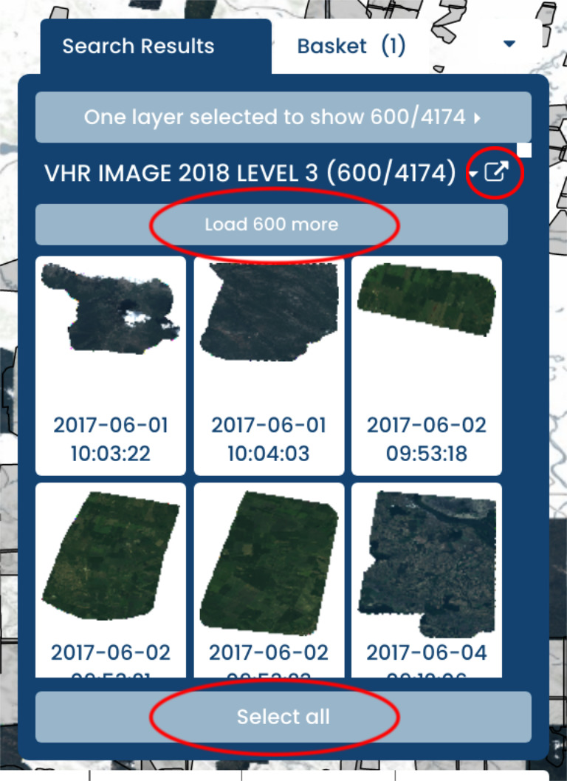
Figure 23 Web Client - Buttons in search panel
Items selected for download can be viewed in the Basket tab (see Figure 24) or Selected button (see Figure 25, single layer mode) on the right panel. To remove an item from the selection use the minus icon visible while hovering over it.
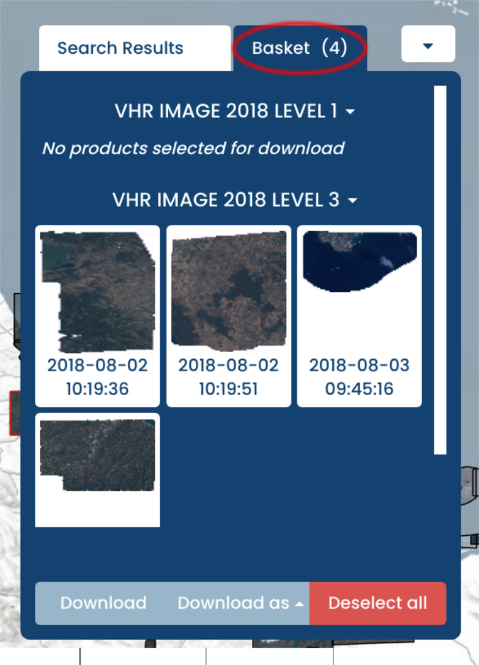
Figure 24 Web Client - Basket
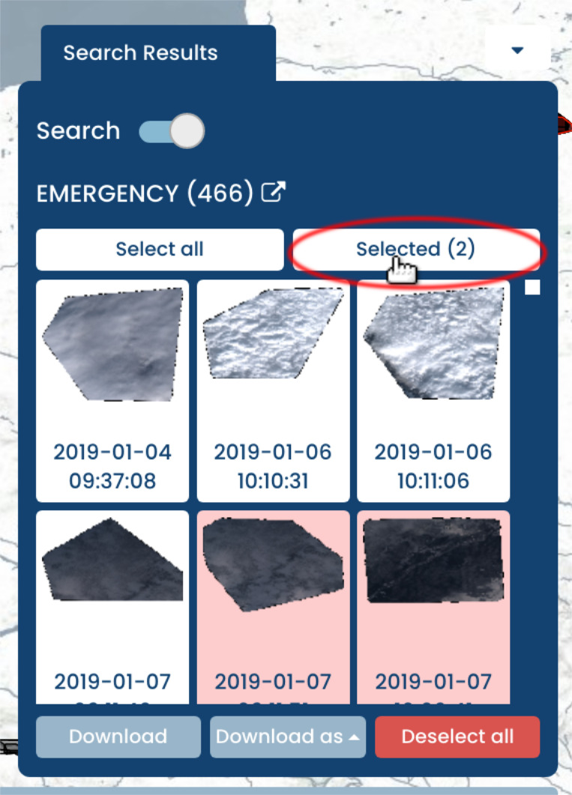
Figure 25 Web Client - Selected

Filters
There are several options to add explicit filters to product queries in the Filters tab in the left panel:
- Spatial filter: allows drawing a Point, Rectangle, or Polygon directly on the map. By default when no explicit spatial filter is set, the current map window extent is used as a spatial filter.
- Time filter: by default the time filter, a simple time interval, is configured via the Timeslider. If enabled, the time filter tool allows a fine grained configuration of the time interval to use for searching.
- Additional filters: based on the configuration provided by the operator additional filters for each layer based on available metadata like “Cloud Coverage” might be available.
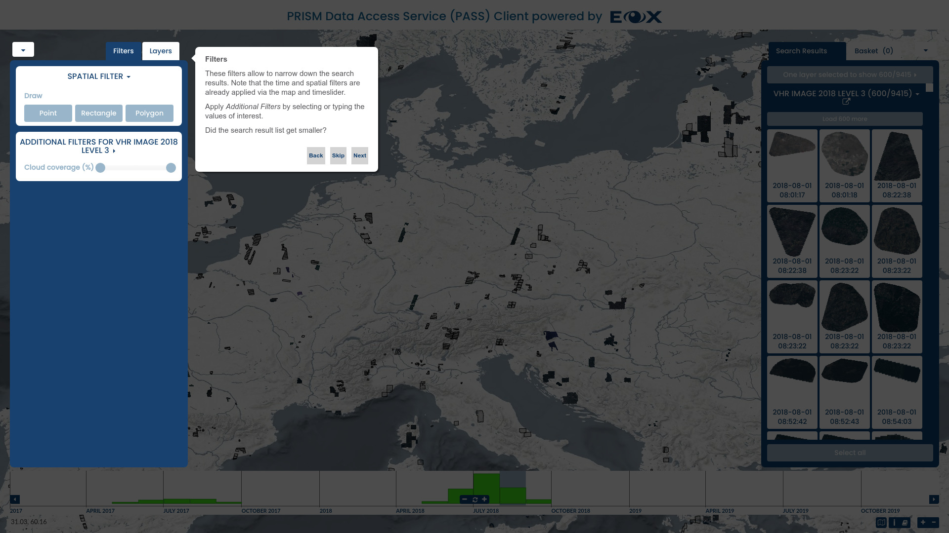
Figure 26 Web Client Tutorial - Filters

Map Layers
The Layers tab in the left panel enables configuring Overlays, Layers, and Base Layers to be shown.
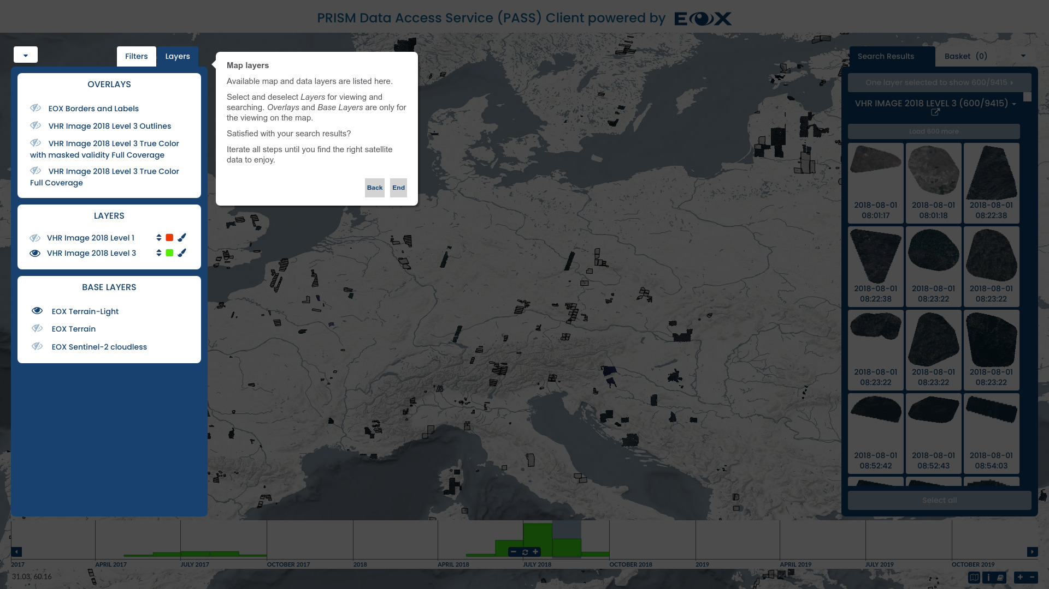
Figure 27 Web Client Tutorial - Map Layers
Base Layers provide various backgrounds whereas Overlays contains configured overlay layers, which can be text labels or other information like footprints, full coverage mosaics (for VHR_IMAGE_2018) or any other configured overlay content to view on top of products for easier orientation on the map. They can be enabled and disabled individually as needed via the eye icon next to their name. Base Layers and Overlays can not be downloaded or searched.
Layers correspond to product collections or datasets. Searching is performed on enabled layers.
The order of layers can be changed by dragging the arrows next to each layer up and down. This influences the order of the rendering on the map as well as in the timeslider.
The visualization (styling) of layers can be changed by clicking on the paint brush icon next to the layer name. The displayed overlay enables setting the layer’s opacity and selecting one of the predefined styles for the layer.
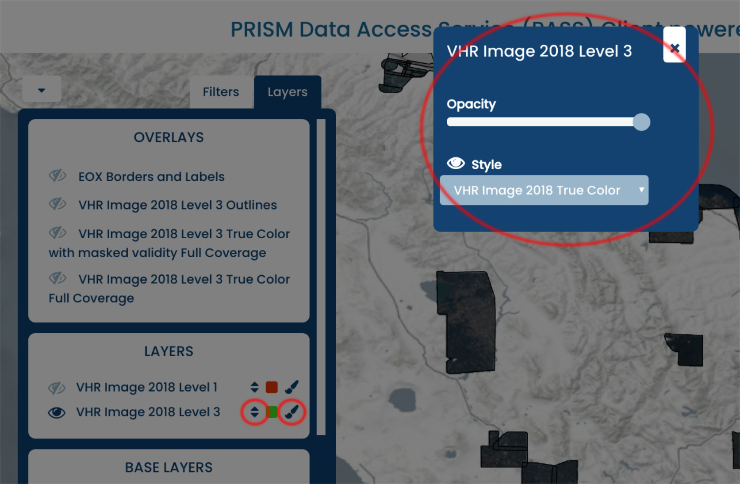
Figure 28 Web Client - Layer configuration
All three types of layers allow clicking on the Layer name to show an information panel with further layer metadata and additional information, together with a visualization GetCapabilities link.
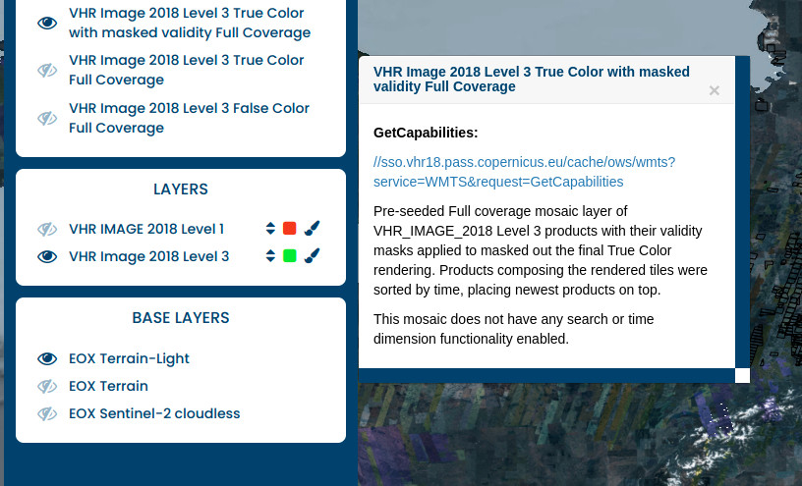
Figure 29 Web Client - Layer Description popup

Details Display
In order to view details of individual products, either click on the info (i) icon after clicking on the product footprint on the map or the product entry in the Search Results panel.
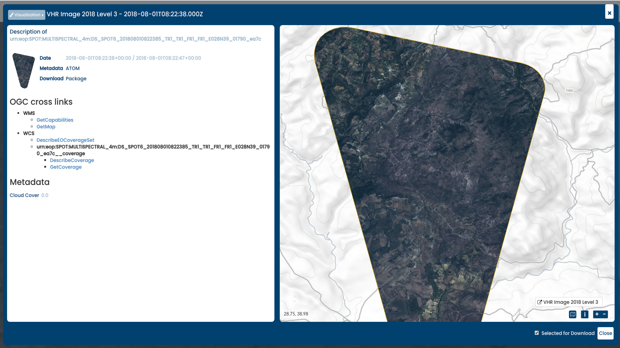
Figure 30 Web Client Details Display
An overlay display will open showing the product metadata as well as the product itself on a map. The product metadata contains links to visualize and download the metadata and product. Those links are OGC standards compliant service requests for OpenSearch (see chapter Searching), WMS (see chapter Viewing), WCS, and DSEO (both see chapter Downloading). The chapter Sample Service Requests provides sample requests for all those services.
The following links are provided:
- Metadata ATOM: download the product’s metadata in ATOM format
- Download Package: download the entire product as stored on object storage
- WMS: GetCapabilities: get the description of the WMS for the individual product for example for inclusion in QGIS
- WMS: GetMap: visualize the individual product using WMS
- WCS: DescribeEOCoverageSet or WCS: DescribeCoverage: get the description of the product’s coverage in WCS
- WCS: GetCoverage: download the product as coverage potentially after adjusting the URL parameters
- WCS: GetEOCoverageSet : download all the products within a coverage’s bounding box,
The visualization of the product layer for this map window can be changed via the Visualization button in the top left corner.
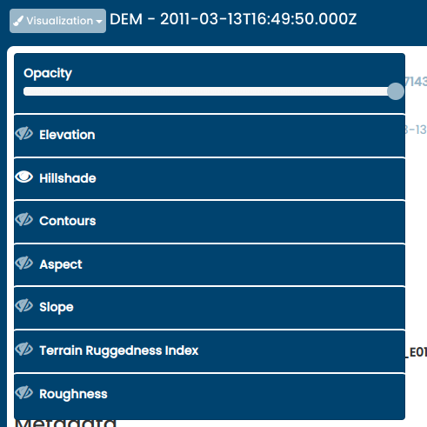
Figure 31 Web Client - Visualization options in detailed display
View Server provides multiple display options, opacity, style, and DEM specific visualization options, such as: Hillshade, Slope, Aspect, Contours, Roughness and Terrain Ruggedness Index. each option has editable parameters (e.g Figure 32 algorithm, altitude, z-factor and azimuth for hillshaded relief)
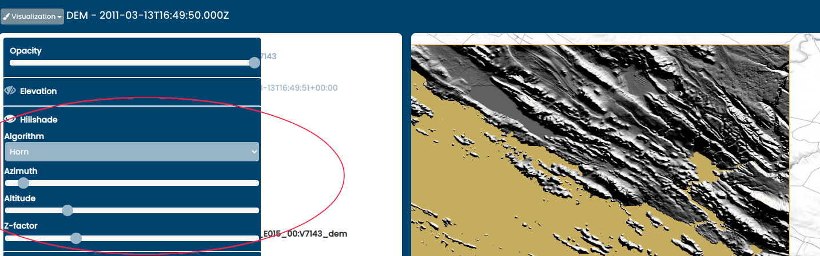
Figure 32 Web Client - Parameter Selection
The product itself can be added to the basket by ticking the check box in the bottom right of the panel.

Download
Several methods for downloading products or only parts of them are exploited by the web client.
After putting one or more products in the basket or selecting them for download, they are listed in the right panel, either on the Search Results tab via the Selected button or on the Basket tab (see section Search Results particularly Figure 24 and Figure 25 above).
To download a full product (image and linked metadata) or a full coverage (just the image), the Details Display of the respective product can be used (see chapter Details Display above).
To download all selected products in parallel or as single packaged folder the Download or Download as buttons on the right panel of the web client can be used.
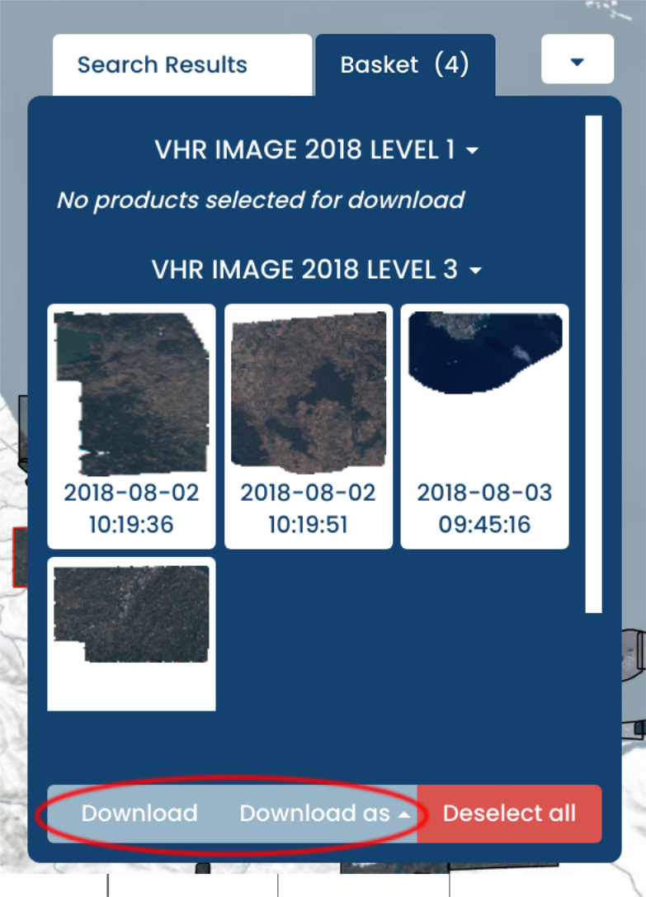
Figure 33 Web Client - Download multiple products
- Download as: offers a Download as URL-List option which downloads a .txt file with a list of download links (Get Coverage requests), a Download as Metalink option allowing for possibly increased speed via segment downloading by metalink-aware software, and -if configured- a Start WPS processes option which lunches a WPS interface.
Download: opens an overlay panel allowing to specify download type: whether to download multiple products in one compressed archive, or to separately download products in a parallel manner. the panel provides the ability to select download parameters for subsetting, projection, format, package type (in case of multidownload), interpolation, and resolution or scaling as shown in Figure 34 below. When multiple products are to be downloaded, the configured options are applied to all of them. Clicking the Download button confirms the selected options and initiates the downloads. Note, if the products are downloaded via WCS, browser might open multiple confirmation dialogs or issue a warning. Besides, modern browsers have a limit of 6 concurrent connections. Popups might need to be explicitly allowed for this site. Usually a server-side limit on the resulting size of a downloaded image in pixels served by WCS protocol is configured in order to not completely exhaust the available resources by a single request for a very large product. If users want to use WCS protocol to download a resulting image larger than the imposed limit, they can use tiling approach by making several smaller requests by subsetting or reduce the required resolution by modifying the scale. Alternatively to download a full product (image and linked metadata) without any limits the user can use the option Download Package (see chapter Details Display above).
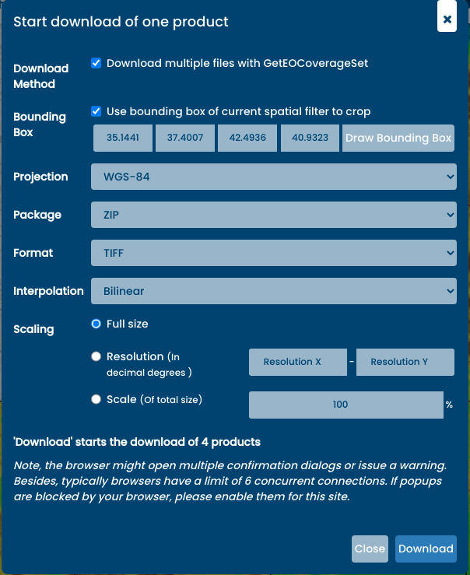
Figure 34 Web Client - Download multiple products via WCS

WPS Processes
The web client provides an interface for some processes, currently mainly related to DEM collection, each process’s settings (such as inputs, outputs….etc) are defined in the client configuration file. Currently, the following processes are provided:
- Height Profile: (DEM) Creates a height profile of a line crossing a DEM tile. provided as PNG, Jpeg, tiff and csv.
- Hillshade Relief: (DEM) Creates a height profile of a line crossing a DEM tile. provided as PNG, Jpeg, and tiff.
- Aspect: (DEM) Creates Aspect which is the orientation of slope of a DEM tile. provided as PNG, Jpeg, and tiff.
- Slope: (DEM) Creates a Slope which is the steepness or the degree of incline of a DEM tile surface. provided as PNG, Jpeg, and tiff.
- Contours: Creates contours of a DEM a tile.. provided as PNG, Jpeg, and tiff.
- Statistics: (all collections) Get statistics for all coverage/s that intersects with the input bounding box.
The interface allows users to select the process they intend to execute. (for example the height profile process shown in Figure 35 below) Once selected, users get to specify process’s parameters ( e.g bbox/line, output format…etc) either as values they insert or selection, spatial values (bbox, line) can also be drawn in the map.
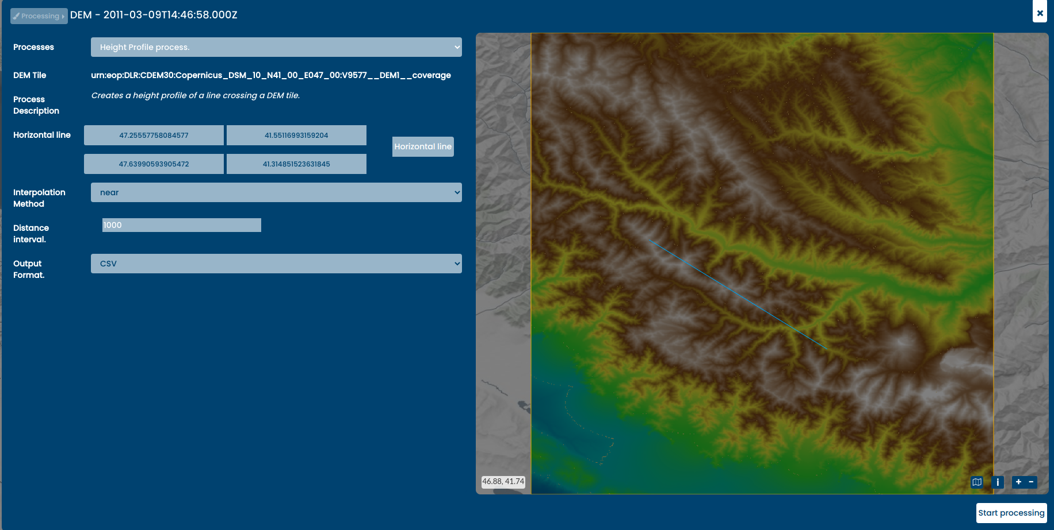
Figure 35 Web Client - Get height process of a selected DEM tile
The processes interface enables users to navigate between selected products using the next & previous buttons in the upper left corner of the panel (figure Figure 36)
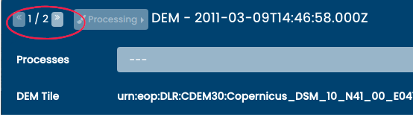
Figure 36 Web Client - Navigate through products
Once all parameters are selected/inserted, clicking the Start Processing button in the lower right corner (see figure Figure 37)
Will send the WPS execute request to the vs renderer to execute the process.
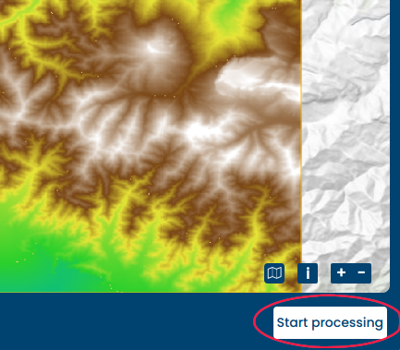
Figure 37 Web Client - start processing

Saving the session
The web client allows to save some parts of its current state by setting the URL search parameters. That enables users to revisit the same view in time and space later on or share the direct link with someone, overruling the default client setup. Please note that certain characters are automatically URL encoded, as URLs sent over the Internet only use the ASCII character set. This means that if user manually enters for example : sign, while entering the website, it will automatically transform into %3A, making the URL less readable.
- Pre-set the map position by setting x, y as coordinates of the center of the map and the zoom with the z parameter. Map position example.
- The time selection is set by timestart and timeend, and should be entered as ISO 8601 UTC time format without milliseconds. Time selection example.
The following chapters describe the services offered for Viewing, Searching, as well as Downloading.

Searching
The main interface for searching is provided by OpenSearch using various extensions including the Geo and Time Extensions, the Extension for Earth Observation as well as the CEOS OpenSearch Best Practice Document.
The OpenSearch URL endpoints are:
- /opensearch: Main service description
- /opensearch/<format>: Search for collections in a specific format
- /opensearch/collections/<collection-id>: Collection specific description
- /opensearch/collections/<collection-id>/<format>: Search for products in a collection in that format

Responses
The description related endpoints provide an OpenSearch Description Document (OSDD). This XML based file format describes general service metadata and various access URL templates.
These URL objects provide templates that can be filled with parameters to submit actual metadata queries. Depending on the used URL, the search result is returned in one of the following formats:
- atom: Atom syndication format
- rss: RSS
- html: HTML
- kml: Keyhole Markup Language
- json: GeoJSON
The resulting items in that result document can be paged. Specific pages can be retrieved using the offset and count parameters. Additionally, the response contains links to the first, last, next, and previous pages of the result set.
The results of the search depend on the type of object being searched. For the collection search, the result items are collection descriptions of all matched collections encoded in the selected format. Each description contains a link to its own specific OSDD document.
In product searches, the result document items are descriptions of products, containing links to thumbnails, browses, and product specific services such as WMS or WCS. Additionally it contains the products acquisition footprint and time stamp.

Filters
The URL templates for both the collection and the record search allow to pass parameters that control the query and shape of the search. The following table shows all parameters available for both collection and product searches:
Parameter | Description
startIndex | The index offset of the items. Used to get subsets of a result set
count | The number of records for each page
start | The start time stamp for the time range
end | The end time stamp for the time range
timerel | The semantic of the time range. Either intersects, contains, disjoint, or equals
bbox | The geographic bounding box expressed as min-lon, min-lat, max-lon, max-lat in WGS84 coordinates
geom | A WKT encoded geometry for a geographic search
lon | The longitude component of point/radius searches
lat | The latitude component of point/radius searches
r | The radious in metres of point/radius searches
georel | The semantic of the geometry filter. One of intersects, contains, or disjoint
The following parameters are only available in product searches in addition to the general search parameters:
Parameter | Description
uid | Filter on identifier
cloudCover | Cloud cover filter. Either a specific value or an interval of values. Values between 0-100
The available parameters depend on the configuration made by the operator.
Samples responses for each of the four URL endpoints are provided in the DEM collections section of the Sample Service Requests chapter.
Continue reading about the provided Downloading services.

Viewing
The viewing interface is implemented following the Web Map Tile Service (WMTS) as well as the Web Map Service (WMS) standards. Both services are implemented by a wide range of client software which makes it as simple as possible to integrate the viewing service as needed.
Service endpoints optimized for performance as well as for flexibility are provided alongside each other. Concrete example URLs demonstrating the capabilities of the various endpoints are provided in the chapter Sample Service Requests.

Performance optimized service
The performance optimized service variant is provided under the path /cache/ows.
This endpoint offers access to predefined visualizations via WMTS and WMS. The GetTile as well as GetMap requests are answered from image tiles cached on object storage when possible. Figure 38 below shows the three predefined visualizations, true color, false color, and NDVI of the same image tile and Figure 39 the unmasked and masked versions using the validity mask of one tile.
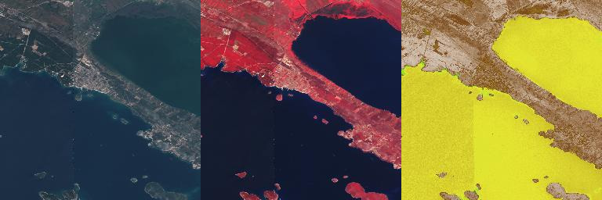
Figure 38 WMTS Tiles - True color, false color, and NDVI
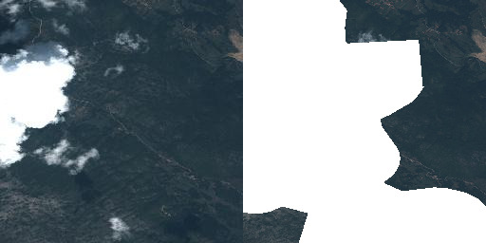
Figure 39 WMTS Tiles - Unmasked and masked
The operator might configure additional layers besides the default ones. These layers can offer a specific customization described below as performance optimized variant.
For example for the VHR Image 2018 dataset not only the three default layers for True Color, False Color, and NDVI are configured but also the Masked Validity one as shown in the figures above.
In addition the VHR Image 2018 dataset contains level 1 and 3 products. Thus individual layers aggregating each level individually are added making the total of offered layers twelve.
Finally two layers are configured offering a quick true color visualization of the entire level 3 datasets without support of the time dimension both unmasked as well as masked. The masked layer is shown in Figure 40 below.
Figure 40 Web Client - Full coverage layer
Image tiles not yet present in the cache are stored upon first hit for consecutive requests. This is the so-called on-demand caching. The operator might decide for optimal performance, even for the first request, to pre-seed the cache. Also a mixed variant with a partly pre-seeded cache for example up to a certain zoom level is possible.
However, this is done fully transparent to the users and the only impact is that they might need to wait slightly longer when they are the first to visualize a certain product.
This service offers access on collection level only. Individual products can be addressed using the time parameter given that they do not cover one another on the time axis.
The best performance is offered at the WMTS interface which serves images tiles as they are cached without the need of any reprocessing. WMS responses are generated on-the-fly from image tiles and might thus need some reprocessing to stitch together and scale image tiles.
Cache WMS endpoint usually configures a maximum pixel size of the resulting rendered image.
More sophisticated reprocessing like reprojection or custom color adjustments are not offered at this endpoint.

Flexible service
The other service variant offered is optimized for the best possible flexibility and can be accessed at the path /ows?. There are no server limits imposed on the pixel size of the rendered images on the flexible endpoint.
This endpoint offers the following customizations via WMS:
- Access to individual products via ID (cql=identifier='ID')
- Access to entire collections/datasets supporting time parameter
- Various layers as defined by the Earth Observation Application Profile of WMS (EO-WMS) like one showing outlines of products (__outlines)
- Additional useful layers like one showing both, products and outlines, correctly rendering topology of outlines (__outlined) or one showing a validity mask (__validity) or applied validity mask (___masked_validity)
- Numerous styles for layer where feasible like outlines or NDVI (layers=ID__NDVI&STYLES=coolwarm)
- Reprojection to operator configured coordinate reference systems
- Color adjustment via custom linear stretch dim_range=<low-red-or-grey> <high-red-or-grey>[,<low-green> <high-green>,<low-blue> <high-blue>]
- Filtering of products to render into collection/dataset visualizations via Common Query Language (CQL) for example &cql=cloudCover<1
- All other standard WMS parameters like transparent, format, etc.
- Eligible products (vhr15/ua2012 and some Emergency products) when configured allow special rendering TRUE_COLOR_PANSHARPENED to perform on-the-fly pansharpening.
- Specifying rendering variables via vendor WMS parameter like in case of DEM__hillshade rendering: VARIABLES=alg=ZevenbergenThorne,azimuth=315,altitude=45,zfactor=1.
All these customization parameters can of course be combined as needed.
Please see the chapter Sample Service Requests for detailed examples of all supported parameters.
Continue reading to learn about the provided Searching services.

Downloading
The download interface is implemented following the Web Coverage Service (WCS) as well as the Download Service for Earth Observation Products Best Practice (DSEO) standards.
These interfaces support both, the simple download of entire products via DSEO as well as flexible customized downloads via WCS. Both services can be accessed at the path /ows?.
The WCS offers the following customizations in order to optimize downloads and minimize unnecessarily used bandwidth:
- Earth Observation Application Profile (EO-WCS)
- Meaningful default configuration
- Spatial subset to retrieve only the geographic area of interest
- Range subset to retrieve only the band(s) of interest
- Scaling to required resolution
- Format selection
- Interpolation selection if needed
- Projection selection
Note that the download size in WCS is restricted in order to not block the service. Clients are advised to download bigger coverages in chunks and put them together afterwards.
Another method of downloading the data is via a service proxying requests to the readily available COGs on object storage. The service supports HTTP range requests in order to allow clients to optimally exploit the capabilities of COGs and is reachable on endpoint /http/storage
The final chapter Sample Service Requests holds a list of sample requests against the various services described in this user guide.

Sample Service Requests
This chapter provides various sample requests. Those requests are against a operational service but still might get obsolete over time. If that is the case, please let us know:
For more information about used authentication and authorization for the purposes of trying out the sample requests yourselves, please have a look at Authentication.

Web Client
The web and services are accessible on the production URL:
- sso.<collection>.pass.copernicus.eu
Currently as of writing these collections/datasets are available:
- VHR IMAGE 2018: https://sso.vhr18.pass.copernicus.eu
- Emergency https://sso.emg.pass.copernicus.eu
- Copernicus DEM Open https://sso.demf.pass.copernicus.eu
- Copernicus DEM Restricted https://sso.dem.pass.copernicus.eu
- Frontex Emergency https://sso.frtx-emg.pass.copernicus.eu
- SatCen Emergency https://sso.sace-emg.pass.copernicus.eu
- Csea Emergency https://sso.csea-emg.pass.copernicus.eu
- VHR IMAGE 2015 https://sso.vhr15.pass.copernicus.eu
- VHR1-2 Urban Atlas 2012 https://sso.ua2012.pass.copernicus.eu
- DWH_MG2_CORE_01 - Optical HR Pan EU Coverages (Image2012) https://sso.core12.pass.copernicus.eu
- DWH_MG2_CORE_02 - Optical HR Pan EU coverages (Image2006 and Image2009) https://sso.core09.pass.copernicus.eu
Some examples of available requests follow.

Performance optimized viewing
WMTS Capabilities
<?xml version="1.0" encoding="UTF-8"?>
<Capabilities version="1.0.0" xmlns="http://www.opengis.net/wmts/1.0" xmlns:gml="http://www.opengis.net/gml" xmlns:inspire_common="http://inspire.ec.europa.eu/schemas/common/1.0" xmlns:inspire_vs="http://inspire.ec.europa.eu/schemas/inspire_vs_ows11/1.0" xmlns:ows="http://www.opengis.net/ows/1.1" xmlns:xlink="http://www.w3.org/1999/xlink" xmlns:xsi="http://www.w3.org/2001/XMLSchema-instance" xsi:schemaLocation="http://www.opengis.net/wmts/1.0 http://schemas.opengis.net/wmts/1.0/wmtsGetCapabilities_response.xsd http://inspire.ec.europa.eu/schemas/inspire_vs_ows11/1.0 http://inspire.ec.europa.eu/schemas/inspire_vs_ows11/1.0/inspire_vs_ows_11.xsd">
<ows:ServiceIdentification>
<ows:Title>PRISM Data Access Service (PASS) developed by EOX</ows:Title>
<ows:Abstract>PRISM Data Access Service (PASS) developed by EOX</ows:Abstract>
<ows:Keywords>
<ows:Keyword>view service</ows:Keyword>
</ows:Keywords>
<ows:ServiceType>OGC WMTS</ows:ServiceType>
<ows:ServiceTypeVersion>1.0.0</ows:ServiceTypeVersion>
<ows:Fees>UNKNOWN</ows:Fees>
<ows:AccessConstraints>UNKNOWN</ows:AccessConstraints>
</ows:ServiceIdentification>
<ows:ServiceProvider>
<stripped/>
</ows:ServiceProvider>
<ows:OperationsMetadata>
<ows:Operation name="GetCapabilities">
<ows:DCP>
<ows:HTTP>
<ows:Get xlink:href="https://sso.vhr18.pass.copernicus.eu/cache/ows/wmts?">
<ows:Constraint name="GetEncoding">
<ows:AllowedValues>
<ows:Value>KVP</ows:Value>
</ows:AllowedValues>
</ows:Constraint>
</ows:Get>
</ows:HTTP>
</ows:DCP>
</ows:Operation>
<ows:Operation name="GetTile">
<ows:DCP>
<ows:HTTP>
<ows:Get xlink:href="https://sso.vhr18.pass.copernicus.eu/cache/ows/wmts?">
<ows:Constraint name="GetEncoding">
<ows:AllowedValues>
<ows:Value>KVP</ows:Value>
</ows:AllowedValues>
</ows:Constraint>
</ows:Get>
</ows:HTTP>
</ows:DCP>
</ows:Operation>
<ows:Operation name="GetFeatureInfo">
<ows:DCP>
<ows:HTTP>
<ows:Get xlink:href="https://sso.vhr18.pass.copernicus.eu/cache/ows/wmts?">
<ows:Constraint name="GetEncoding">
<ows:AllowedValues>
<ows:Value>KVP</ows:Value>
</ows:AllowedValues>
</ows:Constraint>
</ows:Get>
</ows:HTTP>
</ows:DCP>
</ows:Operation>
<inspire_vs:ExtendedCapabilities>
<inspire_common:MetadataUrl xsi:type="inspire_common:resourceLocatorType">
<inspire_common:URL>TBD</inspire_common:URL>
<inspire_common:MediaType>application/vnd.iso.19139+xml</inspire_common:MediaType>
</inspire_common:MetadataUrl>
<inspire_common:SupportedLanguages>
<inspire_common:DefaultLanguage>
<inspire_common:Language>eng</inspire_common:Language>
</inspire_common:DefaultLanguage>
</inspire_common:SupportedLanguages>
<inspire_common:ResponseLanguage>
<inspire_common:Language>eng</inspire_common:Language>
</inspire_common:ResponseLanguage>
</inspire_vs:ExtendedCapabilities>
</ows:OperationsMetadata>
<Contents>
<Layer>
<ows:Title>VHR Image 2018 Level 3 True Color with masked validity</ows:Title>
<ows:Abstract>VHR Image 2018 Level 3 True Color with masked validity</ows:Abstract>
<ows:WGS84BoundingBox>
<ows:LowerCorner>-180.000000 -90.000000</ows:LowerCorner>
<ows:UpperCorner>180.000000 90.000000</ows:UpperCorner>
</ows:WGS84BoundingBox>
<ows:Identifier>VHR_IMAGE_2018_Level_3__masked_validity</ows:Identifier>
<Style isDefault="true">
<ows:Identifier>default</ows:Identifier>
</Style>
<Format>image/unknown</Format>
<Dimension>
<ows:Identifier>time</ows:Identifier>
<Default>2017/2019</Default>
<Value>2017-05-01T09:54:28Z/2019-10-06T07:03:34Z</Value>
</Dimension>
<TileMatrixSetLink>
<TileMatrixSet>WGS84</TileMatrixSet>
</TileMatrixSetLink>
<ResourceURL format="image/unknown" resourceType="tile" template="https://sso.vhr18.pass.copernicus.eu/cache/ows/wmts/1.0.0/VHR_IMAGE_2018_Level_3__masked_validity/default/{time}/{TileMatrixSet}/{TileMatrix}/{TileRow}/{TileCol}.xxx"/>
</Layer>
<Layer>
<ows:Title>VHR Image 2018 Level 3 True Color with masked validity Full Coverage</ows:Title>
<ows:Abstract>VHR Image 2018 Level 3 True Color with masked validity Full Coverage</ows:Abstract>
<ows:WGS84BoundingBox>
<ows:LowerCorner>-24.700000 27.500000</ows:LowerCorner>
<ows:UpperCorner>45.000000 71.300000</ows:UpperCorner>
</ows:WGS84BoundingBox>
<ows:Identifier>VHR_IMAGE_2018_Level_3__masked_validity__Full</ows:Identifier>
<Style isDefault="true">
<ows:Identifier>default</ows:Identifier>
</Style>
<Format>image/unknown</Format>
<TileMatrixSetLink>
<TileMatrixSet>WGS84</TileMatrixSet>
</TileMatrixSetLink>
<ResourceURL format="image/unknown" resourceType="tile" template="https://sso.vhr18.pass.copernicus.eu/cache/ows/wmts/1.0.0/VHR_IMAGE_2018_Level_3__masked_validity__Full/default/{TileMatrixSet}/{TileMatrix}/{TileRow}/{TileCol}.xxx"/>
</Layer>
<stripped_12_layers/>
<TileMatrixSet>
<stripped/>
</TileMatrixSet>
</Contents>
</Capabilities>
WMS Capabilities
<?xml version="1.0" encoding="UTF-8" standalone="no" ?>
<!DOCTYPE WMT_MS_Capabilities
SYSTEM 'http://schemas.opengis.net/wms/1.1.0/capabilities_1_1_0.dtd' [ <!ELEMENT VendorSpecificCapabilities EMPTY>]>
<WMT_MS_Capabilities version="1.1.1">
<Service>
<Name>OGC:WMS</Name>
<Title>PRISM Data Access Service (PASS) developed by EOX</Title>
<OnlineResource xlink:href="https://sso.vhr18.pass.copernicus.eu/cache/ows/?" xmlns:xlink="http://www.w3.org/1999/xlink"/>
</Service>
<Capability>
<Request>
<GetCapabilities>
<Format>application/vnd.ogc.wms_xml</Format>
<DCPType>
<HTTP>
<Get>
<OnlineResource xlink:href="https://sso.vhr18.pass.copernicus.eu/cache/ows/?" xmlns:xlink="http://www.w3.org/1999/xlink"/>
</Get>
</HTTP>
</DCPType>
</GetCapabilities>
<GetMap>
<Format>image/png</Format>
<Format>image/jpeg</Format>
<DCPType>
<HTTP>
<Get>
<OnlineResource xlink:href="https://sso.vhr18.pass.copernicus.eu/cache/ows/?" xmlns:xlink="http://www.w3.org/1999/xlink"/>
</Get>
</HTTP>
</DCPType>
</GetMap>
<GetFeatureInfo>
<Format>text/plain</Format>
<Format>application/vnd.ogc.gml</Format>
<DCPType>
<HTTP>
<Get>
<OnlineResource xlink:href="https://sso.vhr18.pass.copernicus.eu/cache/ows/?" xmlns:xlink="http://www.w3.org/1999/xlink"/>
</Get>
</HTTP>
</DCPType>
</GetFeatureInfo>
</Request>
<Exception>
<Format>text/plain</Format>
</Exception>
<VendorSpecificCapabilities>
<stripped/>
</VendorSpecificCapabilities>
<Layer>
<Title>PRISM Data Access Service (PASS) developed by EOX</Title>
<SRS>EPSG:4326</SRS>
<Layer cascaded="1" queryable="0">
<Name>VHR_IMAGE_2018_Level_3__masked_validity</Name>
<Title>VHR Image 2018 Level 3 True Color with masked validity</Title>
<Abstract>VHR Image 2018 Level 3 True Color with masked validity</Abstract>
<LatLonBoundingBox maxx="180.000000" maxy="90.000000" minx="-180.000000" miny="-90.000000"/>
<Dimension default="2017/2019" name="time">2017-05-01T09:54:28Z/2019-10-06T07:03:34Z</Dimension>
<BoundingBox SRS="EPSG:4326" maxx="180.000000" maxy="90.000000" minx="-180.000000" miny="-90.000000"/>
<SRS>EPSG:4326</SRS>
</Layer>
<Layer cascaded="1" queryable="0">
<Name>VHR_IMAGE_2018_Level_3__masked_validity__Full</Name>
<Title>VHR Image 2018 Level 3 True Color with masked validity Full Coverage</Title>
<Abstract>VHR Image 2018 Level 3 True Color with masked validity Full Coverage</Abstract>
<LatLonBoundingBox maxx="45.000000" maxy="71.300000" minx="-24.700000" miny="27.500000"/>
<BoundingBox SRS="EPSG:4326" maxx="45.000000" maxy="71.300000" minx="-24.700000" miny="27.500000"/>
<SRS>EPSG:4326</SRS>
</Layer>
<stripped_12_layers/>
</Layer>
</Capability>
</WMT_MS_Capabilities>
WMTS True color tile, WMTS False color tile, and WMTS NDVI tile. Same area via WMS request.
True Color non-pansharpened vhr15
Figure 41 WMTS - Non-pansharpened
True Color pansharpened vhr15
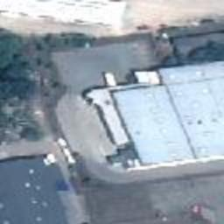
Figure 42 WMTS - Pansharpened
Figure 43 WMTS Tiles - True color, false color, and NDVI
WMTS True color masked validity tile
Figure 44 WMTS Tiles - Unmasked and masked
WMTS Full layer
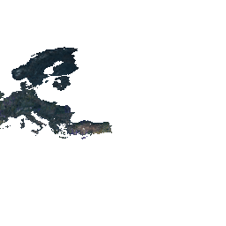
Figure 45 WMTS Tiles - Full layer
WMS Full layer
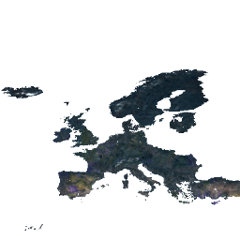
Figure 46 WMS - Full layer

Flexible viewing
Capabilities for collection layers (example below) or Layer capabilities for one product
<?xml version='1.0' encoding='iso-8859-1'?>
<WMS_Capabilities updateSequence="20131219T132000Z" version="1.3.0" xmlns="http://www.opengis.net/wms" xmlns:xlink="http://www.w3.org/1999/xlink" xmlns:xsi="http://www.w3.org/2001/XMLSchema-instance" xsi:schemaLocation="">
<Service>
<Name>PRISM Data Access Service (PASS) developed by EOX</Name>
<Title>PRISM Data Access Service (PASS) developed by EOX</Title>
<Abstract>PRISM Data Access Service (PASS) developed by EOX</Abstract>
<KeywordList>
<Keyword>&lt;KEYWORDLIST&gt;</Keyword>
</KeywordList>
<OnlineResource>http://eoxserver.org</OnlineResource>
<ContactInformation>
<ContactPersonPrimary>
<ContactPerson>&lt;CONTACTPERSON&gt;</ContactPerson>
<ContactOrganization>&lt;CONTACTORGANIZATION&gt;</ContactOrganization>
</ContactPersonPrimary>
<ContactPosition>&lt;CONTACTPOSITION&gt;</ContactPosition>
<ContactAddress>
<AddressType>postal</AddressType>
<Address>&lt;ADDRESS&gt;</Address>
<City>&lt;CITY&gt;</City>
<StateOrProvince>&lt;STATEORPROVINCE&gt;</StateOrProvince>
<PostCode>&lt;POSTCODE&gt;</PostCode>
<Country>&lt;COUNTRY&gt;</Country>
</ContactAddress>
<ContactVoiceTelephone>&lt;CONTACTVOICETELEPHONE&gt;</ContactVoiceTelephone>
<ContactFacsimileTelephone>&lt;CONTACTFACSIMILETELEPHONE&gt;</ContactFacsimileTelephone>
<ContactElectronicMailAddress>&lt;CONTACTELECTRONICMAILADDRESS&gt;</ContactElectronicMailAddress>
</ContactInformation>
<Fees>None</Fees>
<AccessConstraints>None</AccessConstraints>
</Service>
<Capability>
<Request>
<GetCapabilities>
<Format>text/xml</Format>
<DCPType>
<HTTP>
<Get>
<OnlineResource xlink:href="https://sso.vhr18.pass.copernicus.eu/ows" xlink:type="simple"/>
</Get>
</HTTP>
</DCPType>
</GetCapabilities>
<GetMap>
<Format>image/png</Format>
<Format>image/jpeg</Format>
<Format>image/gif</Format>
<Format>image/tiff</Format>
<DCPType>
<HTTP>
<Get>
<OnlineResource xlink:href="https://sso.vhr18.pass.copernicus.eu/ows" xlink:type="simple"/>
</Get>
</HTTP>
</DCPType>
</GetMap>
<GetFeatureInfo>
<Format/>
<DCPType>
<HTTP>
<Get>
<OnlineResource xlink:href="https://sso.vhr18.pass.copernicus.eu/ows" xlink:type="simple"/>
</Get>
</HTTP>
</DCPType>
</GetFeatureInfo>
</Request>
<Exception>
<Format>XML</Format>
<Format>INIMAGE</Format>
<Format>BLANK</Format>
</Exception>
<Layer>
<Title>PRISM Data Access Service (PASS) developed by EOX</Title>
<CRS>EPSG:4326</CRS>
<CRS>EPSG:3857</CRS>
<CRS>EPSG:3035</CRS>
<EX_GeographicBoundingBox>
<westBoundLongitude>-180</westBoundLongitude>
<eastBoundLongitude>180</eastBoundLongitude>
<southBoundLatitude>-90</southBoundLatitude>
<northBoundLatitude>90</northBoundLatitude>
</EX_GeographicBoundingBox>
<stripped_2_layer_groups/>
<Layer queryable="0">
<Name>VHR_IMAGE_2018_Level_3</Name>
<EX_GeographicBoundingBox>
<westBoundLongitude>-24.6397992939</westBoundLongitude>
<eastBoundLongitude>44.8308373419</eastBoundLongitude>
<southBoundLatitude>27.5748429858</southBoundLatitude>
<northBoundLatitude>71.2306420611</northBoundLatitude>
</EX_GeographicBoundingBox>
<Layer queryable="1">
<Name>VHR_IMAGE_2018_Level_3__outlines</Name>
<Style>
<Name>brown</Name>
<Abstract>brown</Abstract>
</Style>
<Style>
<Name>yellow</Name>
<Abstract>yellow</Abstract>
</Style>
<stripped_10_styles/>
</Layer>
<stripped_6_layers/>
<Layer queryable="0">
<Name>VHR_IMAGE_2018_Level_3__masked_validity</Name>
</Layer>
<Dimension default="2018-09-30T13:26:34Z" name="time" units="ISO8601">2017-05-01T09:54:28Z/2018-09-30T13:26:34Z/PT1S</Dimension>
</Layer>
</Layer>
</Capability>
</WMS_Capabilities>
Quicklook
Figure 47 WMS - Quicklook
False color
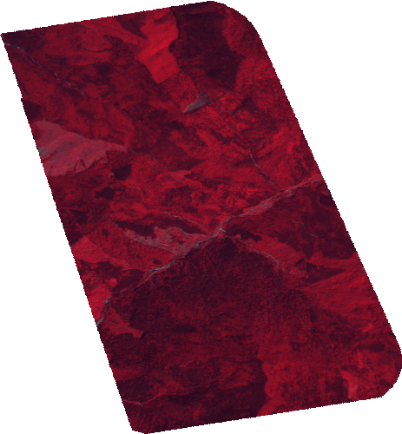
Figure 48 WMS - False color
NDVI including style
Figure 49 WMS - NDVI custom style
Custom color stretch
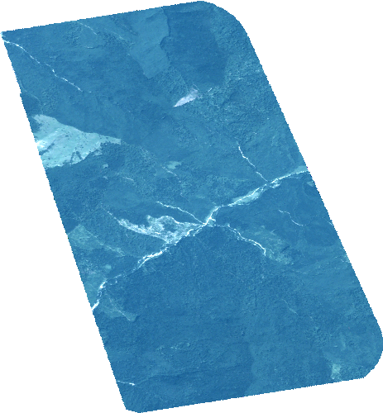
Figure 50 WMS - Custom color stretch
Custom band selection as RGB and color stretch as False color rendering
Figure 51 WMS - Custom bands
CQL filtering on Cloud Coverage
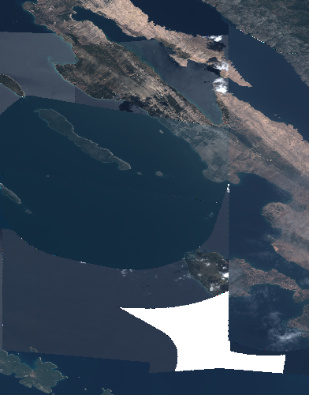
Figure 52 WMS - CQL filtering
Clouds mask
Figure 53 WMS - Clouds mask
Masked clouds
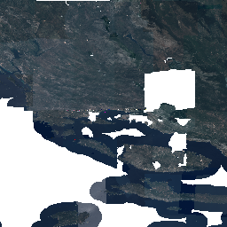
Figure 54 WMS - Masked clouds

DEM collections
DEM collections allow to specify rendering variables via vendor WMS parameter VARIABLES.
Following list summarizes offered renderings for DEM data together with keys and default values, passable into VARIABLES parameter and default dim_range (color stretch) parameter applied.
- elevation (standard DEM elevation rendering), no VARIABLES options. Can be used together with dim_range, STYLE, Default dim_range=-10 4000. Sample elevation rendering with EARTH style
- contours, VARIABLES=offset=0,interval=30. Default dim_range=0 360. Meaning of variables: interval, offset. Sample contours rendering
- aspect, VARIABLES=alg=Horn. Default dim_range=0 360. Meaning of variable: alg. Sample aspect rendering
- hillshade, VARIABLES=zfactor=5,azimuth=315,altitude=45,alg=Horn. Default dim_range=0 255. Meaning of variables: alg, azimuth, altitude. Sample hillshade rendering
- slope, VARIABLES=alg=Horn, Default dim_range 0 50. Sample slope rendering
- roughness, no VARIABLES, Default dim_range=0 20. Sample rougness map rendering
- tri, no VARIABLES, Default dim_range=0 8. Sample Terrain Ruggedness Index (TRI) rendering

Searching
1st step OSDD (stripped to only contain the Atom URL template)
<?xml version='1.0' encoding='iso-8859-1'?>
<OpenSearchDescription xmlns="http://a9.com/-/spec/opensearch/1.1/" xmlns:atom="http://www.w3.org/2005/Atom" xmlns:cql="http://a9.com/-/opensearch/extensions/cql/1.0/" xmlns:eo="http://a9.com/-/opensearch/extensions/eo/1.0/" xmlns:geo="http://a9.com/-/opensearch/extensions/geo/1.0/" xmlns:parameters="http://a9.com/-/spec/opensearch/extensions/parameters/1.0/" xmlns:time="http://a9.com/-/opensearch/extensions/time/1.0/" xmlns:xsi="http://www.w3.org/2001/XMLSchema-instance" xsi:schemaLocation="">
<ShortName/>
<Description/>
<Url indexOffset="0" parameters:enctype="application/x-www-form-urlencoded" parameters:method="GET" rel="collection" template="https://sso.vhr18.pass.copernicus.eu/opensearch/atom/?q={searchTerms?}&amp;count={count?}&amp;startIndex={startIndex?}&amp;collection={eo:collection?}&amp;productType={eo:productType?}&amp;doi={eo:doi?}&amp;platform={eo:platform?}&amp;platformSerialIdentifier={eo:platformSerialIdentifier?}&amp;instrument={eo:instrument?}&amp;sensorType={eo:sensorType?}&amp;compositeType={eo:compositeType?}&amp;processingLevel={eo:processingLevel?}&amp;orbitType={eo:orbitType?}&amp;spectralRange={eo:spectralRange?}&amp;wavelength={eo:wavelength?}&amp;productMetadataSummary={eo:productMetadataSummary?}&amp;coverageMetadataSummary={eo:coverageMetadataSummary?}&amp;bbox={geo:box?}&amp;geom={geo:geometry?}&amp;lon={geo:lon?}&amp;lat={geo:lat?}&amp;r={geo:radius?}&amp;georel={geo:relation?}&amp;uid={geo:uid?}&amp;start={time:start?}&amp;end={time:end?}&amp;timerel={time:relation?}&amp;cql={cql:cql?}" type="application/atom+xml">
<parameters:Parameter maximum="1" minimum="0" name="q" value="{searchTerms}"/>
<parameters:Parameter maxInclusive="200" maximum="1" minInclusive="0" minimum="0" name="count" value="{count}"/>
<parameters:Parameter maximum="1" minInclusive="0" minimum="0" name="startIndex" value="{startIndex}"/>
<parameters:Parameter maximum="1" minimum="0" name="collection" value="{eo:collection}"/>
<parameters:Parameter maximum="1" minimum="0" name="productType" value="{eo:productType}"/>
<parameters:Parameter maximum="1" minimum="0" name="doi" value="{eo:doi}"/>
<parameters:Parameter maximum="1" minimum="0" name="platform" value="{eo:platform}"/>
<parameters:Parameter maximum="1" minimum="0" name="platformSerialIdentifier" value="{eo:platformSerialIdentifier}"/>
<parameters:Parameter maximum="1" minimum="0" name="instrument" value="{eo:instrument}"/>
<parameters:Parameter maximum="1" minimum="0" name="sensorType" value="{eo:sensorType}"/>
<parameters:Parameter maximum="1" minimum="0" name="compositeType" value="{eo:compositeType}"/>
<parameters:Parameter maximum="1" minimum="0" name="processingLevel" value="{eo:processingLevel}"/>
<parameters:Parameter maximum="1" minimum="0" name="orbitType" value="{eo:orbitType}"/>
<parameters:Parameter maximum="1" minimum="0" name="spectralRange" value="{eo:spectralRange}"/>
<parameters:Parameter maximum="1" minimum="0" name="wavelength" value="{eo:wavelength}"/>
<parameters:Parameter maximum="1" minimum="0" name="productMetadataSummary" value="{eo:productMetadataSummary}"/>
<parameters:Parameter maximum="1" minimum="0" name="coverageMetadataSummary" value="{eo:coverageMetadataSummary}"/>
<parameters:Parameter maximum="1" minimum="0" name="bbox" value="{geo:box}"/>
<parameters:Parameter maximum="1" minimum="0" name="geom" value="{geo:geometry}">
<atom:link href="http://www.opengis.net/wkt/LINESTRING" rel="profile" title="This service accepts WKT LineStrings"/>
<atom:link href="http://www.opengis.net/wkt/POINT" rel="profile" title="This service accepts WKT Point"/>
<atom:link href="http://www.opengis.net/wkt/POLYGON" rel="profile" title="This service accepts WKT Polygons"/>
<atom:link href="http://www.opengis.net/wkt/MULTILINESTRING" rel="profile" title="This service accepts WKT Multi-LineStrings"/>
<atom:link href="http://www.opengis.net/wkt/MULTIPOINT" rel="profile" title="This service accepts WKT Multi-Point"/>
<atom:link href="http://www.opengis.net/wkt/MULTIPOLYGON" rel="profile" title="This service accepts WKT Multi-Polygons"/>
</parameters:Parameter>
<parameters:Parameter maximum="1" minimum="0" name="lon" value="{geo:lon}"/>
<parameters:Parameter maximum="1" minimum="0" name="lat" value="{geo:lat}"/>
<parameters:Parameter maximum="1" minimum="0" name="r" value="{geo:radius}"/>
<parameters:Parameter maximum="1" minimum="0" name="georel" value="{geo:relation}">
<parameters:Option label="intersects" value="intersects"/>
<parameters:Option label="contains" value="contains"/>
<parameters:Option label="disjoint" value="disjoint"/>
</parameters:Parameter>
<parameters:Parameter maximum="1" minimum="0" name="uid" value="{geo:uid}"/>
<parameters:Parameter maximum="1" minimum="0" name="start" value="{time:start}"/>
<parameters:Parameter maximum="1" minimum="0" name="end" value="{time:end}"/>
<parameters:Parameter maximum="1" minimum="0" name="timerel" value="{time:relation}">
<parameters:Option label="intersects" value="intersects"/>
<parameters:Option label="contains" value="contains"/>
<parameters:Option label="disjoint" value="disjoint"/>
<parameters:Option label="equals" value="equals"/>
</parameters:Parameter>
<parameters:Parameter maximum="1" minimum="0" name="cql" value="{cql:cql}">
<atom:link href="http://www.opengis.net/csw/3.0/cql" rel="profile" title="CQL (Common Query Language) is a query language created by the OGC for the Catalogue Web Services specification."/>
</parameters:Parameter>
</Url>
<stripped/>
</OpenSearchDescription>
1st step search for collections
<feed xmlns="http://www.w3.org/2005/Atom" xmlns:cql="http://a9.com/-/opensearch/extensions/cql/1.0/" xmlns:dc="http://purl.org/dc/elements/1.1/" xmlns:eo="http://a9.com/-/opensearch/extensions/eo/1.0/" xmlns:geo="http://a9.com/-/opensearch/extensions/geo/1.0/" xmlns:georss="http://www.georss.org/georss" xmlns:media="http://search.yahoo.com/mrss/" xmlns:opensearch="http://a9.com/-/spec/opensearch/1.1/" xmlns:owc="http://www.opengis.net/owc/1.0" xmlns:time="http://a9.com/-/opensearch/extensions/time/1.0/">
<id>https://sso.vhr18.pass.copernicus.eu/opensearch/atom/</id>
<title>None Search</title>
<description/>
<opensearch:totalResults>3</opensearch:totalResults>
<opensearch:startIndex>0</opensearch:startIndex>
<opensearch:itemsPerPage>3</opensearch:itemsPerPage>
<opensearch:Query role="request"/>
<link href="https://sso.vhr18.pass.copernicus.eu/opensearch/" rel="search" type="application/opensearchdescription+xml"/>
<link href="https://sso.vhr18.pass.copernicus.eu/opensearch/atom/" rel="self" type="application/atom+xml"/>
<link href="https://sso.vhr18.pass.copernicus.eu/opensearch/atom/?" rel="first" type="application/atom+xml"/>
<link href="https://sso.vhr18.pass.copernicus.eu/opensearch/atom/?startIndex=0" rel="last" type="application/atom+xml"/>
<entry>
<title>VHR_IMAGE_2018_Level_3</title>
<id>https://sso.vhr18.pass.copernicus.eu/opensearch/atom/?uid=VHR_IMAGE_2018_Level_3</id>
<dc:identifier>VHR_IMAGE_2018_Level_3</dc:identifier>
<dc:date>2017-05-01T09:54:28Z/2018-09-30T13:26:34Z</dc:date>
<georss:box>27.574843 -24.639799 71.230642 44.830837</georss:box>
<georss:where>
<gml:MultiSurface gml:id="multisurface_VHR_IMAGE_2018_Level_3" srsName="EPSG:4326" xmlns:eop="http://www.opengis.net/eop/2.0" xmlns:gml="http://www.opengis.net/gml/3.2" xmlns:gmlcov="http://www.opengis.net/gmlcov/1.0" xmlns:om="http://www.opengis.net/om/2.0">
<gml:surfaceMember>
<gml:Polygon gml:id="polygon_VHR_IMAGE_2018_Level_3">
<gml:exterior>
<gml:LinearRing>
<gml:posList>27.57484299 -24.63979929 71.23064206 -24.63979929 71.23064206 44.83083734 27.57484299 44.83083734 27.57484299 -24.63979929</gml:posList>
</gml:LinearRing>
</gml:exterior>
</gml:Polygon>
</gml:surfaceMember>
</gml:MultiSurface>
</georss:where>
<link href="https://sso.vhr18.pass.copernicus.eu/opensearch/collections/VHR_IMAGE_2018_Level_3/" rel="search" type="application/opensearchdescription+xml"/>
<summary type="html">
<![CDATA[<table><tr><td valign="top" width="10%"><a href="https://sso.vhr18.pass.copernicus.eu/ows?service=WMS&amp;version=1.3.0&amp;request=GetMap&amp;layers=VHR_IMAGE_2018_Level_3&amp;format=image/png&amp;TRANSPARENT=true&amp;width=500&amp;height=314&amp;CRS=EPSG:4326&amp;STYLES=&amp;BBOX=27.574843,-24.639799,71.230642,44.830837" target="_blank" title="View quicklook image"><img align="left" border="0" hspace="8" src="https://sso.vhr18.pass.copernicus.eu/ows?service=WMS&amp;version=1.3.0&amp;request=GetMap&amp;layers=VHR_IMAGE_2018_Level_3&amp;format=image/png&amp;TRANSPARENT=true&amp;width=100&amp;height=62&amp;CRS=EPSG:4326&amp;STYLES=&amp;BBOX=27.574843,-24.639799,71.230642,44.830837" /></a></td><td valign="top" width="90%"><table><tr valign="top"><td><b>Date </b></td><td>2017-05-01T09:54:28+00:00 / 2018-09-30T13:26:34+00:00</td></tr><tr valign="top"><td><b>Metadata</b></td><td><a href="https://sso.vhr18.pass.copernicus.eu/opensearch/atom/?uid=VHR_IMAGE_2018_Level_3" title="Atom format" target="_blank">ATOM</a></td></tr></table></td></tr></table><h3>OGC cross links</h3><ul><li><b>WMS</b><ul><li><a href="https://sso.vhr18.pass.copernicus.eu/ows?service=WMS&amp;request=GetCapabilities&amp;cql=identifier=&#39;VHR_IMAGE_2018_Level_3&#39;" target="_blank">GetCapabilities</a></li></ul><ul><li><a href="https://sso.vhr18.pass.copernicus.eu/ows?service=WMS&amp;version=1.3.0&amp;request=GetMap&amp;layers=VHR_IMAGE_2018_Level_3&amp;format=image/png&amp;TRANSPARENT=true&amp;width=500&amp;height=314&amp;CRS=EPSG:4326&amp;STYLES=&amp;BBOX=27.574843,-24.639799,71.230642,44.830837" target="_blank">GetMap</a></li></ul></li><li><b>WCS</b><ul><li><a href="https://sso.vhr18.pass.copernicus.eu/ows?service=WCS&amp;version=2.0.1&amp;request=DescribeEOCoverageSet&amp;eoId=VHR_IMAGE_2018_Level_3" target="_blank">DescribeEOCoverageSet</a></li></ul></li></ul><h3>Metadata</h3><table></table>]]>
</summary>
</entry>
</feed>
2nd step OSDD (stripped to only contain the Atom URL template)
<?xml version='1.0' encoding='iso-8859-1'?>
<OpenSearchDescription xmlns="http://a9.com/-/spec/opensearch/1.1/" xmlns:atom="http://www.w3.org/2005/Atom" xmlns:cql="http://a9.com/-/opensearch/extensions/cql/1.0/" xmlns:eo="http://a9.com/-/opensearch/extensions/eo/1.0/" xmlns:geo="http://a9.com/-/opensearch/extensions/geo/1.0/" xmlns:parameters="http://a9.com/-/spec/opensearch/extensions/parameters/1.0/" xmlns:time="http://a9.com/-/opensearch/extensions/time/1.0/" xmlns:xsi="http://www.w3.org/2001/XMLSchema-instance" xsi:schemaLocation="">
<ShortName>VHR_IMAGE_2018_Level_3</ShortName>
<Description/>
<Url indexOffset="0" parameters:enctype="application/x-www-form-urlencoded" parameters:method="GET" rel="results" template="https://sso.vhr18.pass.copernicus.eu/opensearch/collections/VHR_IMAGE_2018_Level_3/atom/?q={searchTerms?}&amp;count={count?}&amp;startIndex={startIndex?}&amp;product={eo:product?}&amp;parentIdentifier={eo:parentIdentifier?}&amp;productionStatus={eo:productionStatus?}&amp;acquisitionType={eo:acquisitionType?}&amp;orbitNumber={eo:orbitNumber?}&amp;orbitDirection={eo:orbitDirection?}&amp;track={eo:track?}&amp;frame={eo:frame?}&amp;swathIdentifier={eo:swathIdentifier?}&amp;productVersion={eo:productVersion?}&amp;productQualityStatus={eo:productQualityStatus?}&amp;productQualityDegradationTag={eo:productQualityDegradationTag?}&amp;processorName={eo:processorName?}&amp;processingCenter={eo:processingCenter?}&amp;creationDate={eo:creationDate?}&amp;modificationDate={eo:modificationDate?}&amp;processingDate={eo:processingDate?}&amp;sensorMode={eo:sensorMode?}&amp;archivingCenter={eo:archivingCenter?}&amp;processingMode={eo:processingMode?}&amp;availabilityTime={eo:availabilityTime?}&amp;acquisitionStation={eo:acquisitionStation?}&amp;acquisitionSubType={eo:acquisitionSubType?}&amp;startTimeFromAscendingNode={eo:startTimeFromAscendingNode?}&amp;completionTimeFromAscendingNode={eo:completionTimeFromAscendingNode?}&amp;illuminationAzimuthAngle={eo:illuminationAzimuthAngle?}&amp;illuminationZenithAngle={eo:illuminationZenithAngle?}&amp;illuminationElevationAngle={eo:illuminationElevationAngle?}&amp;polarisationMode={eo:polarisationMode?}&amp;polarizationChannels={eo:polarizationChannels?}&amp;antennaLookDirection={eo:antennaLookDirection?}&amp;minimumIncidenceAngle={eo:minimumIncidenceAngle?}&amp;maximumIncidenceAngle={eo:maximumIncidenceAngle?}&amp;dopplerFrequency={eo:dopplerFrequency?}&amp;incidenceAngleVariation={eo:incidenceAngleVariation?}&amp;cloudCover={eo:cloudCover?}&amp;snowCover={eo:snowCover?}&amp;lowestLocation={eo:lowestLocation?}&amp;highestLocation={eo:highestLocation?}&amp;bbox={geo:box?}&amp;geom={geo:geometry?}&amp;lon={geo:lon?}&amp;lat={geo:lat?}&amp;r={geo:radius?}&amp;georel={geo:relation?}&amp;uid={geo:uid?}&amp;start={time:start?}&amp;end={time:end?}&amp;timerel={time:relation?}&amp;cql={cql:cql?}" type="application/atom+xml">
<parameters:Parameter maximum="1" minimum="0" name="q" value="{searchTerms}"/>
<parameters:Parameter maxInclusive="200" maximum="1" minInclusive="0" minimum="0" name="count" value="{count}"/>
<parameters:Parameter maximum="1" minInclusive="0" minimum="0" name="startIndex" value="{startIndex}"/>
<parameters:Parameter maximum="1" minimum="0" name="product" value="{eo:product}"/>
<parameters:Parameter maximum="1" minimum="0" name="parentIdentifier" value="{eo:parentIdentifier}"/>
<parameters:Parameter maximum="1" minimum="0" name="productionStatus" value="{eo:productionStatus}">
<parameters:Option label="ACQUIRED" value="ACQUIRED"/>
<parameters:Option label="CANCELLED" value="CANCELLED"/>
<parameters:Option label="ARCHIVED" value="ARCHIVED"/>
</parameters:Parameter>
<parameters:Parameter maximum="1" minimum="0" name="acquisitionType" value="{eo:acquisitionType}">
<parameters:Option label="NOMINAL" value="NOMINAL"/>
<parameters:Option label="OTHER" value="OTHER"/>
<parameters:Option label="CALIBRATION" value="CALIBRATION"/>
</parameters:Parameter>
<parameters:Parameter maximum="1" minimum="0" name="orbitNumber" value="{eo:orbitNumber}"/>
<parameters:Parameter maximum="1" minimum="0" name="orbitDirection" value="{eo:orbitDirection}">
<parameters:Option label="DESCENDING" value="DESCENDING"/>
<parameters:Option label="ASCENDING" value="ASCENDING"/>
</parameters:Parameter>
<parameters:Parameter maximum="1" minimum="0" name="track" value="{eo:track}"/>
<parameters:Parameter maximum="1" minimum="0" name="frame" value="{eo:frame}"/>
<parameters:Parameter maximum="1" minimum="0" name="swathIdentifier" value="{eo:swathIdentifier}"/>
<parameters:Parameter maximum="1" minimum="0" name="productVersion" value="{eo:productVersion}"/>
<parameters:Parameter maximum="1" minimum="0" name="productQualityStatus" value="{eo:productQualityStatus}">
<parameters:Option label="DEGRAGED" value="DEGRAGED"/>
<parameters:Option label="NOMINAL" value="NOMINAL"/>
</parameters:Parameter>
<parameters:Parameter maximum="1" minimum="0" name="productQualityDegradationTag" value="{eo:productQualityDegradationTag}"/>
<parameters:Parameter maximum="1" minimum="0" name="processorName" value="{eo:processorName}"/>
<parameters:Parameter maximum="1" minimum="0" name="processingCenter" value="{eo:processingCenter}"/>
<parameters:Parameter maximum="1" minimum="0" name="creationDate" value="{eo:creationDate}"/>
<parameters:Parameter maximum="1" minimum="0" name="modificationDate" value="{eo:modificationDate}"/>
<parameters:Parameter maximum="1" minimum="0" name="processingDate" value="{eo:processingDate}"/>
<parameters:Parameter maximum="1" minimum="0" name="sensorMode" value="{eo:sensorMode}"/>
<parameters:Parameter maximum="1" minimum="0" name="archivingCenter" value="{eo:archivingCenter}"/>
<parameters:Parameter maximum="1" minimum="0" name="processingMode" value="{eo:processingMode}"/>
<parameters:Parameter maximum="1" minimum="0" name="availabilityTime" value="{eo:availabilityTime}"/>
<parameters:Parameter maximum="1" minimum="0" name="acquisitionStation" value="{eo:acquisitionStation}"/>
<parameters:Parameter maximum="1" minimum="0" name="acquisitionSubType" value="{eo:acquisitionSubType}"/>
<parameters:Parameter maximum="1" minimum="0" name="startTimeFromAscendingNode" value="{eo:startTimeFromAscendingNode}"/>
<parameters:Parameter maximum="1" minimum="0" name="completionTimeFromAscendingNode" value="{eo:completionTimeFromAscendingNode}"/>
<parameters:Parameter maximum="1" minimum="0" name="illuminationAzimuthAngle" value="{eo:illuminationAzimuthAngle}"/>
<parameters:Parameter maximum="1" minimum="0" name="illuminationZenithAngle" value="{eo:illuminationZenithAngle}"/>
<parameters:Parameter maximum="1" minimum="0" name="illuminationElevationAngle" value="{eo:illuminationElevationAngle}"/>
<parameters:Parameter maximum="1" minimum="0" name="polarisationMode" value="{eo:polarisationMode}">
<parameters:Option label="quad" value="quad"/>
<parameters:Option label="single" value="single"/>
<parameters:Option label="twin" value="twin"/>
<parameters:Option label="dual" value="dual"/>
<parameters:Option label="UNDEFINED" value="UNDEFINED"/>
</parameters:Parameter>
<parameters:Parameter maximum="1" minimum="0" name="polarizationChannels" value="{eo:polarizationChannels}">
<parameters:Option label="UNDEFINED" value="UNDEFINED"/>
<parameters:Option label="VH" value="VH"/>
<parameters:Option label="HH, HV" value="HH, HV"/>
<parameters:Option label="HH, HV, VH, VV" value="HH, HV, VH, VV"/>
<parameters:Option label="HV" value="HV"/>
<parameters:Option label="HH, VV" value="HH, VV"/>
<parameters:Option label="HH, VH" value="HH, VH"/>
<parameters:Option label="VV, HV" value="VV, HV"/>
<parameters:Option label="HH" value="HH"/>
<parameters:Option label="HV, VH" value="HV, VH"/>
<parameters:Option label="VV" value="VV"/>
<parameters:Option label="VH, VV" value="VH, VV"/>
<parameters:Option label="VH, HV" value="VH, HV"/>
<parameters:Option label="VV, VH" value="VV, VH"/>
</parameters:Parameter>
<parameters:Parameter maximum="1" minimum="0" name="antennaLookDirection" value="{eo:antennaLookDirection}">
<parameters:Option label="RIGHT" value="RIGHT"/>
<parameters:Option label="LEFT" value="LEFT"/>
</parameters:Parameter>
<parameters:Parameter maximum="1" minimum="0" name="minimumIncidenceAngle" value="{eo:minimumIncidenceAngle}"/>
<parameters:Parameter maximum="1" minimum="0" name="maximumIncidenceAngle" value="{eo:maximumIncidenceAngle}"/>
<parameters:Parameter maximum="1" minimum="0" name="dopplerFrequency" value="{eo:dopplerFrequency}"/>
<parameters:Parameter maximum="1" minimum="0" name="incidenceAngleVariation" value="{eo:incidenceAngleVariation}"/>
<parameters:Parameter maximum="1" minimum="0" name="cloudCover" value="{eo:cloudCover}"/>
<parameters:Parameter maximum="1" minimum="0" name="snowCover" value="{eo:snowCover}"/>
<parameters:Parameter maximum="1" minimum="0" name="lowestLocation" value="{eo:lowestLocation}"/>
<parameters:Parameter maximum="1" minimum="0" name="highestLocation" value="{eo:highestLocation}"/>
<parameters:Parameter maximum="1" minimum="0" name="bbox" value="{geo:box}"/>
<parameters:Parameter maximum="1" minimum="0" name="geom" value="{geo:geometry}">
<atom:link href="http://www.opengis.net/wkt/LINESTRING" rel="profile" title="This service accepts WKT LineStrings"/>
<atom:link href="http://www.opengis.net/wkt/POINT" rel="profile" title="This service accepts WKT Point"/>
<atom:link href="http://www.opengis.net/wkt/POLYGON" rel="profile" title="This service accepts WKT Polygons"/>
<atom:link href="http://www.opengis.net/wkt/MULTILINESTRING" rel="profile" title="This service accepts WKT Multi-LineStrings"/>
<atom:link href="http://www.opengis.net/wkt/MULTIPOINT" rel="profile" title="This service accepts WKT Multi-Point"/>
<atom:link href="http://www.opengis.net/wkt/MULTIPOLYGON" rel="profile" title="This service accepts WKT Multi-Polygons"/>
</parameters:Parameter>
<parameters:Parameter maximum="1" minimum="0" name="lon" value="{geo:lon}"/>
<parameters:Parameter maximum="1" minimum="0" name="lat" value="{geo:lat}"/>
<parameters:Parameter maximum="1" minimum="0" name="r" value="{geo:radius}"/>
<parameters:Parameter maximum="1" minimum="0" name="georel" value="{geo:relation}">
<parameters:Option label="intersects" value="intersects"/>
<parameters:Option label="contains" value="contains"/>
<parameters:Option label="disjoint" value="disjoint"/>
</parameters:Parameter>
<parameters:Parameter maximum="1" minimum="0" name="uid" value="{geo:uid}"/>
<parameters:Parameter maximum="1" minimum="0" name="start" value="{time:start}"/>
<parameters:Parameter maximum="1" minimum="0" name="end" value="{time:end}"/>
<parameters:Parameter maximum="1" minimum="0" name="timerel" value="{time:relation}">
<parameters:Option label="intersects" value="intersects"/>
<parameters:Option label="contains" value="contains"/>
<parameters:Option label="disjoint" value="disjoint"/>
<parameters:Option label="equals" value="equals"/>
</parameters:Parameter>
<parameters:Parameter maximum="1" minimum="0" name="cql" value="{cql:cql}">
<atom:link href="http://www.opengis.net/csw/3.0/cql" rel="profile" title="CQL (Common Query Language) is a query language created by the OGC for the Catalogue Web Services specification."/>
</parameters:Parameter>
</Url>
<stripped/>
</OpenSearchDescription>
2nd step search and 2nd step search returning one product
<feed xmlns="http://www.w3.org/2005/Atom" xmlns:cql="http://a9.com/-/opensearch/extensions/cql/1.0/" xmlns:dc="http://purl.org/dc/elements/1.1/" xmlns:eo="http://a9.com/-/opensearch/extensions/eo/1.0/" xmlns:geo="http://a9.com/-/opensearch/extensions/geo/1.0/" xmlns:georss="http://www.georss.org/georss" xmlns:media="http://search.yahoo.com/mrss/" xmlns:opensearch="http://a9.com/-/spec/opensearch/1.1/" xmlns:owc="http://www.opengis.net/owc/1.0" xmlns:time="http://a9.com/-/opensearch/extensions/time/1.0/">
<id>https://sso.vhr18.pass.copernicus.eu/opensearch/collections/VHR_IMAGE_2018_Level_3/atom/?uid=urn:eop:DOVE:MULTISPECTRAL_4m:20180811_081455_1054_3be7</id>
<title>VHR_IMAGE_2018_Level_3 Search</title>
<description/>
<opensearch:totalResults>1</opensearch:totalResults>
<opensearch:startIndex>0</opensearch:startIndex>
<opensearch:itemsPerPage>1</opensearch:itemsPerPage>
<opensearch:Query geo:uid="urn:eop:DOVE:MULTISPECTRAL_4m:20180811_081455_1054_3be7" role="request"/>
<link href="https://sso.vhr18.pass.copernicus.eu/opensearch/" rel="search" type="application/opensearchdescription+xml"/>
<link href="https://sso.vhr18.pass.copernicus.eu/opensearch/collections/VHR_IMAGE_2018_Level_3/atom/?uid=urn:eop:DOVE:MULTISPECTRAL_4m:20180811_081455_1054_3be7" rel="self" type="application/atom+xml"/>
<link href="https://sso.vhr18.pass.copernicus.eu/opensearch/collections/VHR_IMAGE_2018_Level_3/atom/?uid=urn%3Aeop%3ADOVE%3AMULTISPECTRAL_4m%3A20180811_081455_1054_3be7" rel="first" type="application/atom+xml"/>
<link href="https://sso.vhr18.pass.copernicus.eu/opensearch/collections/VHR_IMAGE_2018_Level_3/atom/?startIndex=0&amp;uid=urn%3Aeop%3ADOVE%3AMULTISPECTRAL_4m%3A20180811_081455_1054_3be7" rel="last" type="application/atom+xml"/>
<entry>
<title>urn:eop:DOVE:MULTISPECTRAL_4m:20180811_081455_1054_3be7</title>
<id>https://sso.vhr18.pass.copernicus.eu/opensearch/collections/VHR_IMAGE_2018_Level_3/atom/?uid=urn:eop:DOVE:MULTISPECTRAL_4m:20180811_081455_1054_3be7</id>
<dc:identifier>urn:eop:DOVE:MULTISPECTRAL_4m:20180811_081455_1054_3be7</dc:identifier>
<dc:date>2018-08-11T08:14:55Z</dc:date>
<georss:box>47.297788 25.978201 47.372606 26.047511</georss:box>
<georss:where>
<gml:MultiSurface gml:id="multisurface_urn:eop:DOVE:MULTISPECTRAL_4m:20180811_081455_1054_3be7" srsName="EPSG:4326" xmlns:eop="http://www.opengis.net/eop/2.0" xmlns:gml="http://www.opengis.net/gml/3.2" xmlns:gmlcov="http://www.opengis.net/gmlcov/1.0" xmlns:om="http://www.opengis.net/om/2.0">
<gml:surfaceMember>
<gml:Polygon gml:id="polygon_urn:eop:DOVE:MULTISPECTRAL_4m:20180811_081455_1054_3be7_1">
<gml:exterior>
<gml:LinearRing>
<gml:posList>47.29778796 26.00330821 47.29784395 26.00300545 47.29852855 26.00098039 47.33176050 25.98961353 47.35564999 25.98157482 47.35572189 25.98204011 47.36693204 25.97820059 47.37260630 26.01455420 47.37197192 26.01658883 47.37098788 26.01863079 47.36976416 26.02036682 47.36834411 26.02173541 47.36677806 26.02268812 47.31293985 26.04698765 47.31114307 26.04751063 47.30931486 26.04748521 47.30753117 26.04691252 47.30586607 26.04581637 47.30438870 26.04424235 47.30409927 26.04377423 47.29778796 26.00330821</gml:posList>
</gml:LinearRing>
</gml:exterior>
</gml:Polygon>
</gml:surfaceMember>
</gml:MultiSurface>
</georss:where>
<link href="https://sso.vhr18.pass.copernicus.eu/ows?service=DSEO&amp;version=1.0.0&amp;request=GetProduct&amp;ProductURI=urn:eop:DOVE:MULTISPECTRAL_4m:20180811_081455_1054_3be7" rel="enclosure"/>
<media:content url="https://sso.vhr18.pass.copernicus.eu/ows?service=WMS&amp;version=1.3.0&amp;request=GetMap&amp;layers=urn:eop:DOVE:MULTISPECTRAL_4m:20180811_081455_1054_3be7&amp;format=image/png&amp;TRANSPARENT=true&amp;width=463&amp;height=500&amp;CRS=EPSG:4326&amp;STYLES=&amp;BBOX=47.297788,25.978201,47.372606,26.047511">
<media:category>QUICKLOOK</media:category>
</media:content>
<media:content url="https://sso.vhr18.pass.copernicus.eu/ows?service=WMS&amp;version=1.3.0&amp;request=GetMap&amp;layers=urn:eop:DOVE:MULTISPECTRAL_4m:20180811_081455_1054_3be7&amp;format=image/png&amp;TRANSPARENT=true&amp;width=92&amp;height=100&amp;CRS=EPSG:4326&amp;STYLES=&amp;BBOX=47.297788,25.978201,47.372606,26.047511">
<media:category>THUMBNAIL</media:category>
</media:content>
<owc:offering code="http://www.opengis.net/spec/owc-atom/1.0/req/wms">
<owc:operation code="GetCapabilities" href="https://sso.vhr18.pass.copernicus.eu/ows?service=WMS&amp;request=GetCapabilities&amp;cql=identifier='urn:eop:DOVE:MULTISPECTRAL_4m:20180811_081455_1054_3be7'" method="GET" type="application/xml"/>
<owc:operation code="GetMap" href="https://sso.vhr18.pass.copernicus.eu/ows?service=WMS&amp;version=1.3.0&amp;request=GetMap&amp;layers=urn:eop:DOVE:MULTISPECTRAL_4m:20180811_081455_1054_3be7&amp;format=image/png&amp;TRANSPARENT=true&amp;width=463&amp;height=500&amp;CRS=EPSG:4326&amp;STYLES=&amp;BBOX=47.297788,25.978201,47.372606,26.047511" method="GET" type="image/png"/>
</owc:offering>
<owc:offering code="http://www.opengis.net/spec/owc-atom/1.0/req/wcs">
<owc:operation code="GetCapabilities" href="https://sso.vhr18.pass.copernicus.eu/ows?service=WCS&amp;version=2.0.1&amp;request=GetCapabilities" method="GET" type="application/xml"/>
<owc:operation code="DescribeCoverage" href="https://sso.vhr18.pass.copernicus.eu/ows?service=WCS&amp;version=2.0.1&amp;request=DescribeCoverage&amp;coverageId=urn:eop:DOVE:MULTISPECTRAL_4m:20180811_081455_1054_3be7__coverage" method="GET" type="application/xml"/>
<owc:operation code="GetCoverage" href="https://sso.vhr18.pass.copernicus.eu/ows?service=WCS&amp;version=2.0.1&amp;request=GetCoverage&amp;coverageId=urn:eop:DOVE:MULTISPECTRAL_4m:20180811_081455_1054_3be7__coverage" method="GET" type="image/tiff"/>
</owc:offering>
<summary type="html">
<![CDATA[<table><tr><td valign="top" width="10%"><a href="https://sso.vhr18.pass.copernicus.eu/ows?service=WMS&amp;version=1.3.0&amp;request=GetMap&amp;layers=urn:eop:DOVE:MULTISPECTRAL_4m:20180811_081455_1054_3be7&amp;format=image/png&amp;TRANSPARENT=true&amp;width=463&amp;height=500&amp;CRS=EPSG:4326&amp;STYLES=&amp;BBOX=47.297788,25.978201,47.372606,26.047511" target="_blank" title="View quicklook image"><img align="left" border="0" hspace="8" src="https://sso.vhr18.pass.copernicus.eu/ows?service=WMS&amp;version=1.3.0&amp;request=GetMap&amp;layers=urn:eop:DOVE:MULTISPECTRAL_4m:20180811_081455_1054_3be7&amp;format=image/png&amp;TRANSPARENT=true&amp;width=92&amp;height=100&amp;CRS=EPSG:4326&amp;STYLES=&amp;BBOX=47.297788,25.978201,47.372606,26.047511" /></a></td><td valign="top" width="90%"><table><tr valign="top"><td><b>Date </b></td><td>2018-08-11T08:14:55+00:00 / 2018-08-11T08:14:55+00:00</td></tr><tr valign="top"><td><b>Metadata</b></td><td><a href="https://sso.vhr18.pass.copernicus.eu/opensearch/collections/VHR_IMAGE_2018_Level_3/atom/?uid=urn:eop:DOVE:MULTISPECTRAL_4m:20180811_081455_1054_3be7" title="Atom format" target="_blank">ATOM</a></td></tr><tr valign="top"><td><b>Download</b></td><td><a href="https://sso.vhr18.pass.copernicus.eu/ows?service=DSEO&amp;version=1.0.0&amp;request=GetProduct&amp;ProductURI=urn:eop:DOVE:MULTISPECTRAL_4m:20180811_081455_1054_3be7" title="Download" target="_blank">Package</a></td></tr></table></td></tr></table><h3>OGC cross links</h3><ul><li><b>WMS</b><ul><li><a href="https://sso.vhr18.pass.copernicus.eu/ows?service=WMS&amp;request=GetCapabilities&amp;cql=identifier=&#39;urn:eop:DOVE:MULTISPECTRAL_4m:20180811_081455_1054_3be7&#39;" target="_blank">GetCapabilities</a></li></ul><ul><li><a href="https://sso.vhr18.pass.copernicus.eu/ows?service=WMS&amp;version=1.3.0&amp;request=GetMap&amp;layers=urn:eop:DOVE:MULTISPECTRAL_4m:20180811_081455_1054_3be7&amp;format=image/png&amp;TRANSPARENT=true&amp;width=463&amp;height=500&amp;CRS=EPSG:4326&amp;STYLES=&amp;BBOX=47.297788,25.978201,47.372606,26.047511" target="_blank">GetMap</a></li></ul></li><li><b>WCS</b><ul><li><a href="https://sso.vhr18.pass.copernicus.eu/ows?service=WCS&amp;version=2.0.1&amp;request=DescribeEOCoverageSet&amp;eoId=urn:eop:DOVE:MULTISPECTRAL_4m:20180811_081455_1054_3be7" target="_blank">DescribeEOCoverageSet</a></li><li><b>urn:eop:DOVE:MULTISPECTRAL_4m:20180811_081455_1054_3be7__coverage</b><ul><li><a href="https://sso.vhr18.pass.copernicus.eu/ows?service=WCS&amp;version=2.0.1&amp;request=DescribeCoverage&amp;coverageId=urn:eop:DOVE:MULTISPECTRAL_4m:20180811_081455_1054_3be7__coverage" target="_blank">DescribeCoverage</a></li><li><a href="https://sso.vhr18.pass.copernicus.eu/ows?service=WCS&amp;version=2.0.1&amp;request=GetCoverage&amp;coverageId=urn:eop:DOVE:MULTISPECTRAL_4m:20180811_081455_1054_3be7__coverage" target="_blank">GetCoverage</a></li></ul></li></ul></li></ul><h3>Metadata</h3><table><tr><td>Cloud Cover</td><td>0.0</td></tr></table>]]>
</summary>
</entry>
</feed>
Query inside a polygon and with set time interval
Query inside a bounding box

Downloading

WCS
WCS Capabilities
<?xml version='1.0' encoding='iso-8859-1'?>
<wcs:Capabilities updateSequence="20131219T132000Z" version="2.0.1" xmlns:crs="http://www.opengis.net/wcs/crs/1.0" xmlns:eop="http://www.opengis.net/eop/2.0" xmlns:gml="http://www.opengis.net/gml/3.2" xmlns:gmlcov="http://www.opengis.net/gmlcov/1.0" xmlns:int="http://www.opengis.net/wcs/interpolation/1.0" xmlns:ogc="http://www.opengis.net/ogc" xmlns:om="http://www.opengis.net/om/2.0" xmlns:ows="http://www.opengis.net/ows/2.0" xmlns:rsub="http://www.opengis.net/wcs/range-subsetting/1.0" xmlns:scal="http://www.opengis.net/wcs/scaling/1.0" xmlns:swe="http://www.opengis.net/swe/2.0" xmlns:wcs="http://www.opengis.net/wcs/2.0" xmlns:wcseo="http://www.opengis.net/wcs/wcseo/1.0" xmlns:xlink="http://www.w3.org/1999/xlink" xmlns:xsi="http://www.w3.org/2001/XMLSchema-instance" xsi:schemaLocation="http://www.opengis.net/ows/2.0 http://schemas.opengis.net/ows/2.0/owsAll.xsd http://www.opengis.net/wcs/wcseo/1.0 http://schemas.opengis.net/wcs/wcseo/1.0/wcsEOAll.xsd">
<ows:ServiceIdentification>
<ows:Title>PRISM Data Access Service (PASS) developed by EOX</ows:Title>
<ows:Abstract>PRISM Data Access Service (PASS) developed by EOX</ows:Abstract>
<ows:Keywords>
<ows:Keyword>&lt;KEYWORDLIST&gt;</ows:Keyword>
</ows:Keywords>
<ows:ServiceType codeSpace="OGC">OGC WCS</ows:ServiceType>
<ows:ServiceTypeVersion>2.0.1</ows:ServiceTypeVersion>
<ows:ServiceTypeVersion>2.0.0</ows:ServiceTypeVersion>
<ows:ServiceTypeVersion>1.1.2</ows:ServiceTypeVersion>
<ows:ServiceTypeVersion>1.1.1</ows:ServiceTypeVersion>
<ows:ServiceTypeVersion>1.1.0</ows:ServiceTypeVersion>
<ows:ServiceTypeVersion>1.0.0</ows:ServiceTypeVersion>
<ows:Profile>http://www.opengis.net/spec/WCS_application-profile_earth-observation/1.0/conf/eowcs</ows:Profile>
<ows:Profile>http://www.opengis.net/spec/WCS_application-profile_earth-observation/1.0/conf/eowcs_get-kvp</ows:Profile>
<ows:Profile>http://www.opengis.net/spec/WCS_service-extension_crs/1.0/conf/crs</ows:Profile>
<ows:Profile>http://www.opengis.net/spec/WCS/2.0/conf/core</ows:Profile>
<ows:Profile>http://www.opengis.net/spec/WCS_protocol-binding_get-kvp/1.0/conf/get-kvp</ows:Profile>
<ows:Profile>http://www.opengis.net/spec/WCS_protocol-binding_post-xml/1.0/conf/post-xml</ows:Profile>
<ows:Profile>http://www.opengis.net/spec/GMLCOV/1.0/conf/gml-coverage</ows:Profile>
<ows:Profile>http://www.opengis.net/spec/GMLCOV/1.0/conf/multipart</ows:Profile>
<ows:Profile>http://www.opengis.net/spec/GMLCOV/1.0/conf/special-format</ows:Profile>
<ows:Profile>http://www.opengis.net/spec/GMLCOV_geotiff-coverages/1.0/conf/geotiff-coverage</ows:Profile>
<ows:Profile>http://www.opengis.net/spec/WCS_geotiff-coverages/1.0/conf/geotiff-coverage</ows:Profile>
<ows:Profile>http://www.opengis.net/spec/WCS_service-model_crs-predefined/1.0/conf/crs-predefined</ows:Profile>
<ows:Profile>http://www.opengis.net/spec/WCS_service-extension_interpolation/1.0/conf/interpolation</ows:Profile>
<ows:Profile>http://www.opengis.net/spec/WCS_service-extension_range-subsetting/1.0/conf/record-subsetting</ows:Profile>
<ows:Profile>http://www.opengis.net/spec/WCS_service-extension_scaling/1.0/conf/scaling</ows:Profile>
<ows:Fees>None</ows:Fees>
<ows:AccessConstraints>None</ows:AccessConstraints>
</ows:ServiceIdentification>
<ows:ServiceProvider>
<ows:ProviderName>&lt;CONTACTORGANIZATION&gt;</ows:ProviderName>
<ows:ProviderSite xlink:href="&lt;URL&gt;" xlink:type="simple"/>
<ows:ServiceContact>
<ows:IndividualName>&lt;CONTACTPERSON&gt;</ows:IndividualName>
<ows:PositionName>&lt;CONTACTPOSITION&gt;</ows:PositionName>
<ows:ContactInfo>
<ows:Phone>
<ows:Voice>&lt;CONTACTVOICETELEPHONE&gt;</ows:Voice>
<ows:Facsimile>&lt;CONTACTFACSIMILETELEPHONE&gt;</ows:Facsimile>
</ows:Phone>
<ows:Address>
<ows:DeliveryPoint>&lt;ADDRESS&gt;</ows:DeliveryPoint>
<ows:City>&lt;CITY&gt;</ows:City>
<ows:AdministrativeArea>&lt;STATEORPROVINCE&gt;</ows:AdministrativeArea>
<ows:PostalCode>&lt;POSTCODE&gt;</ows:PostalCode>
<ows:Country>&lt;COUNTRY&gt;</ows:Country>
<ows:ElectronicMailAddress>&lt;CONTACTELECTRONICMAILADDRESS&gt;</ows:ElectronicMailAddress>
</ows:Address>
<ows:OnlineResource xlink:href="http://eoxserver.org" xlink:type="simple"/>
<ows:HoursOfService>&lt;HOURSOFSERVICE&gt;</ows:HoursOfService>
<ows:ContactInstructions>&lt;CONTACTINSTRUCTIONS&gt;</ows:ContactInstructions>
</ows:ContactInfo>
<ows:Role>Service provider</ows:Role>
</ows:ServiceContact>
</ows:ServiceProvider>
<ows:OperationsMetadata>
<ows:Operation name="GetCapabilities">
<ows:DCP>
<ows:HTTP>
<ows:Get xlink:href="pdas/ows?" xlink:type="simple"/>
<ows:Post xlink:href="pdas/ows?" xlink:type="simple">
<ows:Constraint name="PostEncoding">
<ows:AllowedValues>
<ows:Value>XML</ows:Value>
</ows:AllowedValues>
</ows:Constraint>
</ows:Post>
</ows:HTTP>
</ows:DCP>
</ows:Operation>
<ows:Operation name="DescribeCoverage">
<ows:DCP>
<ows:HTTP>
<ows:Get xlink:href="pdas/ows?" xlink:type="simple"/>
<ows:Post xlink:href="pdas/ows?" xlink:type="simple">
<ows:Constraint name="PostEncoding">
<ows:AllowedValues>
<ows:Value>XML</ows:Value>
</ows:AllowedValues>
</ows:Constraint>
</ows:Post>
</ows:HTTP>
</ows:DCP>
</ows:Operation>
<ows:Operation name="GetCoverage">
<ows:DCP>
<ows:HTTP>
<ows:Get xlink:href="pdas/ows?" xlink:type="simple"/>
<ows:Post xlink:href="pdas/ows?" xlink:type="simple">
<ows:Constraint name="PostEncoding">
<ows:AllowedValues>
<ows:Value>XML</ows:Value>
</ows:AllowedValues>
</ows:Constraint>
</ows:Post>
</ows:HTTP>
</ows:DCP>
</ows:Operation>
<ows:Operation name="DescribeEOCoverageSet">
<ows:DCP>
<ows:HTTP>
<ows:Get xlink:href="pdas/ows?" xlink:type="simple"/>
<ows:Post xlink:href="pdas/ows?" xlink:type="simple">
<ows:Constraint name="PostEncoding">
<ows:AllowedValues>
<ows:Value>XML</ows:Value>
</ows:AllowedValues>
</ows:Constraint>
</ows:Post>
</ows:HTTP>
</ows:DCP>
<ows:Constraint name="CountDefault">
<ows:NoValues/>
<ows:DefaultValue>10</ows:DefaultValue>
</ows:Constraint>
</ows:Operation>
<ows:Operation name="GetEOCoverageSet">
<ows:DCP>
<ows:HTTP>
<ows:Get xlink:href="pdas/ows?" xlink:type="simple"/>
<ows:Post xlink:href="pdas/ows?" xlink:type="simple">
<ows:Constraint name="PostEncoding">
<ows:AllowedValues>
<ows:Value>XML</ows:Value>
</ows:AllowedValues>
</ows:Constraint>
</ows:Post>
</ows:HTTP>
</ows:DCP>
<ows:Constraint name="CountDefault">
<ows:NoValues/>
<ows:DefaultValue>10</ows:DefaultValue>
</ows:Constraint>
</ows:Operation>
</ows:OperationsMetadata>
<wcs:ServiceMetadata>
<wcs:formatSupported>image/tiff</wcs:formatSupported>
<wcs:formatSupported>image/jp2</wcs:formatSupported>
<wcs:formatSupported>application/x-netcdf</wcs:formatSupported>
<wcs:formatSupported>application/x-hdf</wcs:formatSupported>
<wcs:Extension>
<crs:CrsMetadata>
<crs:crsSupported>http://www.opengis.net/def/crs/EPSG/0/4326</crs:crsSupported>
<crs:crsSupported>http://www.opengis.net/def/crs/EPSG/0/3857</crs:crsSupported>
<crs:crsSupported>http://www.opengis.net/def/crs/EPSG/0/3035</crs:crsSupported>
</crs:CrsMetadata>
<int:InterpolationMetadata>
<int:InterpolationSupported>http://www.opengis.net/def/interpolation/OGC/1/average</int:InterpolationSupported>
<int:InterpolationSupported>http://www.opengis.net/def/interpolation/OGC/1/nearest-neighbour</int:InterpolationSupported>
<int:InterpolationSupported>http://www.opengis.net/def/interpolation/OGC/1/bilinear</int:InterpolationSupported>
<int:InterpolationSupported>http://www.opengis.net/def/interpolation/OGC/1/cubic</int:InterpolationSupported>
<int:InterpolationSupported>http://www.opengis.net/def/interpolation/OGC/1/cubic-spline</int:InterpolationSupported>
<int:InterpolationSupported>http://www.opengis.net/def/interpolation/OGC/1/lanczos</int:InterpolationSupported>
<int:InterpolationSupported>http://www.opengis.net/def/interpolation/OGC/1/mode</int:InterpolationSupported>
</int:InterpolationMetadata>
</wcs:Extension>
</wcs:ServiceMetadata>
<wcs:Contents>
<wcs:Extension>
<wcseo:DatasetSeriesSummary>
<ows:WGS84BoundingBox>
<ows:LowerCorner>12.136296 -24.639799</ows:LowerCorner>
<ows:UpperCorner>71.230642 52.293404</ows:UpperCorner>
</ows:WGS84BoundingBox>
<wcseo:DatasetSeriesId>VHR_IMAGE_2018</wcseo:DatasetSeriesId>
<gml:TimePeriod gml:id="VHR_IMAGE_2018_timeperiod">
<gml:beginPosition>2017-05-01T09:54:28Z</gml:beginPosition>
<gml:endPosition>2019-10-06T07:03:34Z</gml:endPosition>
</gml:TimePeriod>
</wcseo:DatasetSeriesSummary>
<wcseo:DatasetSeriesSummary>
<ows:WGS84BoundingBox>
<ows:LowerCorner>27.574843 -24.639799</ows:LowerCorner>
<ows:UpperCorner>71.230642 44.830837</ows:UpperCorner>
</ows:WGS84BoundingBox>
<wcseo:DatasetSeriesId>VHR_IMAGE_2018_Level_1</wcseo:DatasetSeriesId>
<gml:TimePeriod gml:id="VHR_IMAGE_2018_Level_1_timeperiod">
<gml:beginPosition>2017-05-01T09:54:28Z</gml:beginPosition>
<gml:endPosition>2018-09-30T13:26:34Z</gml:endPosition>
</gml:TimePeriod>
</wcseo:DatasetSeriesSummary>
<wcseo:DatasetSeriesSummary>
<ows:WGS84BoundingBox>
<ows:LowerCorner>27.574843 -24.639799</ows:LowerCorner>
<ows:UpperCorner>71.230642 44.830837</ows:UpperCorner>
</ows:WGS84BoundingBox>
<wcseo:DatasetSeriesId>VHR_IMAGE_2018_Level_3</wcseo:DatasetSeriesId>
<gml:TimePeriod gml:id="VHR_IMAGE_2018_Level_3_timeperiod">
<gml:beginPosition>2017-05-01T09:54:28Z</gml:beginPosition>
<gml:endPosition>2018-09-30T13:26:34Z</gml:endPosition>
</gml:TimePeriod>
</wcseo:DatasetSeriesSummary>
</wcs:Extension>
</wcs:Contents>
</wcs:Capabilities>
EO Coverage set description and Coverage description
<?xml version='1.0' encoding='iso-8859-1'?>
<wcs:CoverageDescriptions xmlns:crs="http://www.opengis.net/wcs/crs/1.0" xmlns:eop="http://www.opengis.net/eop/2.0" xmlns:gml="http://www.opengis.net/gml/3.2" xmlns:gmlcov="http://www.opengis.net/gmlcov/1.0" xmlns:int="http://www.opengis.net/wcs/interpolation/1.0" xmlns:ogc="http://www.opengis.net/ogc" xmlns:om="http://www.opengis.net/om/2.0" xmlns:ows="http://www.opengis.net/ows/2.0" xmlns:rsub="http://www.opengis.net/wcs/range-subsetting/1.0" xmlns:scal="http://www.opengis.net/wcs/scaling/1.0" xmlns:swe="http://www.opengis.net/swe/2.0" xmlns:wcs="http://www.opengis.net/wcs/2.0" xmlns:wcseo="http://www.opengis.net/wcs/wcseo/1.0" xmlns:xlink="http://www.w3.org/1999/xlink" xmlns:xsi="http://www.w3.org/2001/XMLSchema-instance" xsi:schemaLocation="http://www.opengis.net/wcs/wcseo/1.0 http://schemas.opengis.net/wcs/wcseo/1.0/wcsEOAll.xsd">
<wcs:CoverageDescription gml:id="urn:eop:DOVE:MULTISPECTRAL_4m:20180811_081455_1054_3be7__coverage">
<gml:boundedBy>
<gml:Envelope axisLabels="y x" srsDimension="2" srsName="http://www.opengis.net/def/crs/EPSG/0/3035" uomLabels="m m">
<gml:lowerCorner>2817620.000 5518044.000</gml:lowerCorner>
<gml:upperCorner>2825972.000 5524488.000</gml:upperCorner>
</gml:Envelope>
</gml:boundedBy>
<wcs:CoverageId>urn:eop:DOVE:MULTISPECTRAL_4m:20180811_081455_1054_3be7__coverage</wcs:CoverageId>
<gmlcov:metadata>
<gmlcov:Extension>
<wcseo:EOMetadata>
<eop:EarthObservation gml:id="eop_urn:eop:DOVE:MULTISPECTRAL_4m:20180811_081455_1054_3be7__coverage">
<om:phenomenonTime>
<gml:TimePeriod gml:id="phen_time_urn:eop:DOVE:MULTISPECTRAL_4m:20180811_081455_1054_3be7__coverage">
<gml:beginPosition>2018-08-11T08:14:55Z</gml:beginPosition>
<gml:endPosition>2018-08-11T08:14:55Z</gml:endPosition>
</gml:TimePeriod>
</om:phenomenonTime>
<om:resultTime>
<gml:TimeInstant gml:id="res_time_urn:eop:DOVE:MULTISPECTRAL_4m:20180811_081455_1054_3be7__coverage">
<gml:timePosition>2018-08-11T08:14:55Z</gml:timePosition>
</gml:TimeInstant>
</om:resultTime>
<om:procedure/>
<om:observedProperty/>
<om:featureOfInterest>
<eop:Footprint gml:id="footprint_urn:eop:DOVE:MULTISPECTRAL_4m:20180811_081455_1054_3be7__coverage">
<eop:multiExtentOf>
<gml:MultiSurface gml:id="multisurface_urn:eop:DOVE:MULTISPECTRAL_4m:20180811_081455_1054_3be7__coverage" srsName="EPSG:4326">
<gml:surfaceMember>
<gml:Polygon gml:id="polygon_urn:eop:DOVE:MULTISPECTRAL_4m:20180811_081455_1054_3be7__coverage_1">
<gml:exterior>
<gml:LinearRing>
<gml:posList>47.29778796 26.00330821 47.29784395 26.00300545 47.29852855 26.00098039 47.33176050 25.98961353 47.35564999 25.98157482 47.35572189 25.98204011 47.36693204 25.97820059 47.37260630 26.01455420 47.37197192 26.01658883 47.37098788 26.01863079 47.36976416 26.02036682 47.36834411 26.02173541 47.36677806 26.02268812 47.31293985 26.04698765 47.31114307 26.04751063 47.30931486 26.04748521 47.30753117 26.04691252 47.30586607 26.04581637 47.30438870 26.04424235 47.30409927 26.04377423 47.29778796 26.00330821</gml:posList>
</gml:LinearRing>
</gml:exterior>
</gml:Polygon>
</gml:surfaceMember>
</gml:MultiSurface>
</eop:multiExtentOf>
</eop:Footprint>
</om:featureOfInterest>
<om:result/>
<eop:metaDataProperty>
<eop:EarthObservationMetaData>
<eop:identifier>urn:eop:DOVE:MULTISPECTRAL_4m:20180811_081455_1054_3be7__coverage</eop:identifier>
<eop:acquisitionType>NOMINAL</eop:acquisitionType>
<eop:status>ARCHIVED</eop:status>
</eop:EarthObservationMetaData>
</eop:metaDataProperty>
</eop:EarthObservation>
</wcseo:EOMetadata>
</gmlcov:Extension>
</gmlcov:metadata>
<gml:domainSet>
<gml:RectifiedGrid dimension="2" gml:id="urn:eop:DOVE:MULTISPECTRAL_4m:20180811_081455_1054_3be7__coverage_grid">
<gml:limits>
<gml:GridEnvelope>
<gml:low>0 0</gml:low>
<gml:high>1610 2087</gml:high>
</gml:GridEnvelope>
</gml:limits>
<gml:axisLabels>y x</gml:axisLabels>
<gml:origin>
<gml:Point gml:id="urn:eop:DOVE:MULTISPECTRAL_4m:20180811_081455_1054_3be7__coverage_grid_origin" srsName="http://www.opengis.net/def/crs/EPSG/0/3035">
<gml:pos>2825972.000 5518044.000</gml:pos>
</gml:Point>
</gml:origin>
<gml:offsetVector srsName="http://www.opengis.net/def/crs/EPSG/0/3035">0.000 4.000</gml:offsetVector>
<gml:offsetVector srsName="http://www.opengis.net/def/crs/EPSG/0/3035">-4.000 0.000</gml:offsetVector>
</gml:RectifiedGrid>
</gml:domainSet>
<gmlcov:rangeType>
<swe:DataRecord>
<swe:field name="red">
<swe:Quantity definition="http://www.opengis.net/def/property/OGC/0/Radiance">
<swe:description>Red Channel</swe:description>
<swe:nilValues>
<swe:NilValues>
<swe:nilValue reason="http://www.opengis.net/def/nil/OGC/0/unknown">0</swe:nilValue>
</swe:NilValues>
</swe:nilValues>
<swe:uom code="W.m-2.Sr-1"/>
<swe:constraint>
<swe:AllowedValues>
<swe:interval>0 65535</swe:interval>
<swe:significantFigures>5</swe:significantFigures>
</swe:AllowedValues>
</swe:constraint>
</swe:Quantity>
</swe:field>
<swe:field name="green">
<swe:Quantity definition="http://www.opengis.net/def/property/OGC/0/Radiance">
<swe:description>Green Channel</swe:description>
<swe:nilValues>
<swe:NilValues>
<swe:nilValue reason="http://www.opengis.net/def/nil/OGC/0/unknown">0</swe:nilValue>
</swe:NilValues>
</swe:nilValues>
<swe:uom code="W.m-2.Sr-1"/>
<swe:constraint>
<swe:AllowedValues>
<swe:interval>0 65535</swe:interval>
<swe:significantFigures>5</swe:significantFigures>
</swe:AllowedValues>
</swe:constraint>
</swe:Quantity>
</swe:field>
<swe:field name="blue">
<swe:Quantity definition="http://www.opengis.net/def/property/OGC/0/Radiance">
<swe:description>Blue Channel</swe:description>
<swe:nilValues>
<swe:NilValues>
<swe:nilValue reason="http://www.opengis.net/def/nil/OGC/0/unknown">0</swe:nilValue>
</swe:NilValues>
</swe:nilValues>
<swe:uom code="W.m-2.Sr-1"/>
<swe:constraint>
<swe:AllowedValues>
<swe:interval>0 65535</swe:interval>
<swe:significantFigures>5</swe:significantFigures>
</swe:AllowedValues>
</swe:constraint>
</swe:Quantity>
</swe:field>
<swe:field name="nir">
<swe:Quantity definition="http://www.opengis.net/def/property/OGC/0/Radiance">
<swe:description>Nir Channel</swe:description>
<swe:nilValues>
<swe:NilValues>
<swe:nilValue reason="http://www.opengis.net/def/nil/OGC/0/unknown">0</swe:nilValue>
</swe:NilValues>
</swe:nilValues>
<swe:uom code="W.m-2.Sr-1"/>
<swe:constraint>
<swe:AllowedValues>
<swe:interval>0 65535</swe:interval>
<swe:significantFigures>5</swe:significantFigures>
</swe:AllowedValues>
</swe:constraint>
</swe:Quantity>
</swe:field>
</swe:DataRecord>
</gmlcov:rangeType>
<wcs:ServiceParameters>
<wcs:CoverageSubtype>RectifiedDataset</wcs:CoverageSubtype>
<wcs:nativeFormat>image/tiff</wcs:nativeFormat>
</wcs:ServiceParameters>
</wcs:CoverageDescription>
</wcs:CoverageDescriptions>

WCS Download Links
Download two EO Coverages together as a zipped archive
Full coverage in default configuration
Spatial subset
Range subset
Scaled down
Specifying size as number of pixels in both axis
Specific format and interpolation
Specific projection
Download returning HTML exception in case of too large image requested

DSEO
One entire product

HTTP access
HTTP proxy access to a single coverage, allowing range headers - add ‘Range: bytes=0-500’ to request headers

Processing
List available processes on WPS via GetCapabilities request
Get parameters of a WPS process via DescribeProcess request
All following sample Execute WPS requests can be sent towards DEM Free collection on URL: https://sso.demf.pass.copernicus.eu/ows as a POST request with following request body:

WPS 1.0
Execute DemProcessing Hillshade with JPG output for a smaller part of DEM Tile:
<?xml version="1.0" encoding="UTF-8"?>
<wps:Execute xmlns:wps="http://www.opengis.net/wps/1.0.0" xmlns:ows="http://www.opengis.net/ows/1.1" xmlns:xlink="http://www.w3.org/1999/xlink" xmlns:xsi="http://www.w3.org/2001/XMLSchema-instance" service="WPS" version="1.0.0" xsi:schemaLocation="http://www.opengis.net/wps/1.0.0 http://schemas.opengis.net/wps/1.0.0/wpsExecute_request.xsd">
<ows:Identifier>DemProcessing</ows:Identifier>
<wps:DataInputs>
<wps:Input>
<ows:Identifier>algorithm</ows:Identifier>
<wps:Data>
<wps:LiteralData>ZevenbergenThorne</wps:LiteralData>
</wps:Data>
</wps:Input>
<wps:Input>
<ows:Identifier>azimuth</ows:Identifier>
<wps:Data>
<wps:LiteralData>30</wps:LiteralData>
</wps:Data>
</wps:Input>
<wps:Input>
<ows:Identifier>altitude</ows:Identifier>
<wps:Data>
<wps:LiteralData>25</wps:LiteralData>
</wps:Data>
</wps:Input>
<wps:Input>
<ows:Identifier>z_factor</ows:Identifier>
<wps:Data>
<wps:LiteralData>2</wps:LiteralData>
</wps:Data>
</wps:Input>
<wps:Input>
<ows:Identifier>bbox</ows:Identifier>
<wps:Data>
<wps:LiteralData>9.21525795269168,45.47809186378467,9.56925469004894,45.814144066068515</wps:LiteralData>
</wps:Data>
</wps:Input>
<wps:Input>
<ows:Identifier>identifier</ows:Identifier>
<wps:Data>
<wps:LiteralData>hillshade</wps:LiteralData>
</wps:Data>
</wps:Input>
<wps:Input>
<ows:Identifier>scale</ows:Identifier>
<wps:Data>
<wps:LiteralData>111120</wps:LiteralData>
</wps:Data>
</wps:Input>
<wps:Input>
<ows:Identifier>coverage</ows:Identifier>
<wps:Data>
<wps:LiteralData>urn:eop:DLR:CDEM30:Copernicus_DSM_10_N45_00_E009_00:VelVH-2019_2__DEM1__coverage</wps:LiteralData>
</wps:Data>
</wps:Input>
</wps:DataInputs>
<wps:ResponseForm>
<wps:RawDataOutput mimeType="image/jpeg">
<ows:Identifier>result</ows:Identifier>
</wps:RawDataOutput>
</wps:ResponseForm>
</wps:Execute>
Execute DemProcessing Slope with GeoTIFF output for a smaller part of DEM Tile
<?xml version="1.0" encoding="UTF-8"?>
<wps:Execute xmlns:wps="http://www.opengis.net/wps/1.0.0" xmlns:ows="http://www.opengis.net/ows/1.1" xmlns:xlink="http://www.w3.org/1999/xlink" xmlns:xsi="http://www.w3.org/2001/XMLSchema-instance" service="WPS" version="1.0.0" xsi:schemaLocation="http://www.opengis.net/wps/1.0.0 http://schemas.opengis.net/wps/1.0.0/wpsExecute_request.xsd">
<ows:Identifier>DemProcessing</ows:Identifier>
<wps:DataInputs>
<wps:Input>
<ows:Identifier>algorithm</ows:Identifier>
<wps:Data>
<wps:LiteralData>ZevenbergenThorne</wps:LiteralData>
</wps:Data>
</wps:Input>
<wps:Input>
<ows:Identifier>bbox</ows:Identifier>
<wps:Data>
<wps:LiteralData>9.69731341761827,45.61022889477977,9.933855016313213,45.854927100326265</wps:LiteralData>
</wps:Data>
</wps:Input>
<wps:Input>
<ows:Identifier>identifier</ows:Identifier>
<wps:Data>
<wps:LiteralData>slopeshade</wps:LiteralData>
</wps:Data>
</wps:Input>
<wps:Input>
<ows:Identifier>scale</ows:Identifier>
<wps:Data>
<wps:LiteralData>111120</wps:LiteralData>
</wps:Data>
</wps:Input>
<wps:Input>
<ows:Identifier>coverage</ows:Identifier>
<wps:Data>
<wps:LiteralData>urn:eop:DLR:CDEM30:Copernicus_DSM_10_N45_00_E009_00:VelVH-2019_2__DEM1__coverage</wps:LiteralData>
</wps:Data>
</wps:Input>
</wps:DataInputs>
<wps:ResponseForm>
<wps:RawDataOutput mimeType="image/tiff">
<ows:Identifier>result</ows:Identifier>
</wps:RawDataOutput>
</wps:ResponseForm>
</wps:Execute>
Execute DemProcessing Aspect with PNG output for a smaller part of DEM Tile
<?xml version="1.0" encoding="UTF-8"?>
<wps:Execute xmlns:wps="http://www.opengis.net/wps/1.0.0" xmlns:ows="http://www.opengis.net/ows/1.1" xmlns:xlink="http://www.w3.org/1999/xlink" xmlns:xsi="http://www.w3.org/2001/XMLSchema-instance" service="WPS" version="1.0.0" xsi:schemaLocation="http://www.opengis.net/wps/1.0.0 http://schemas.opengis.net/wps/1.0.0/wpsExecute_request.xsd">
<ows:Identifier>DemProcessing</ows:Identifier>
<wps:DataInputs>
<wps:Input>
<ows:Identifier>algorithm</ows:Identifier>
<wps:Data>
<wps:LiteralData>Horn</wps:LiteralData>
</wps:Data>
</wps:Input>
<wps:Input>
<ows:Identifier>bbox</ows:Identifier>
<wps:Data>
<wps:LiteralData>9.574964314845024,45.62280783038122,9.811992349776046,45.929967883360526</wps:LiteralData>
</wps:Data>
</wps:Input>
<wps:Input>
<ows:Identifier>identifier</ows:Identifier>
<wps:Data>
<wps:LiteralData>aspect</wps:LiteralData>
</wps:Data>
</wps:Input>
<wps:Input>
<ows:Identifier>coverage</ows:Identifier>
<wps:Data>
<wps:LiteralData>urn:eop:DLR:CDEM30:Copernicus_DSM_10_N45_00_E009_00:VelVH-2019_2__DEM1__coverage</wps:LiteralData>
</wps:Data>
</wps:Input>
</wps:DataInputs>
<wps:ResponseForm>
<wps:RawDataOutput mimeType="image/png">
<ows:Identifier>result</ows:Identifier>
</wps:RawDataOutput>
</wps:ResponseForm>
</wps:Execute>
Execute DemProcessing Contour 50m interval with GeoJSON output for a smaller part of DEM Tile
<?xml version="1.0" encoding="UTF-8"?>
<wps:Execute xmlns:wps="http://www.opengis.net/wps/1.0.0" xmlns:ows="http://www.opengis.net/ows/1.1" xmlns:xlink="http://www.w3.org/1999/xlink" xmlns:xsi="http://www.w3.org/2001/XMLSchema-instance" service="WPS" version="1.0.0" xsi:schemaLocation="http://www.opengis.net/wps/1.0.0 http://schemas.opengis.net/wps/1.0.0/wpsExecute_request.xsd">
<ows:Identifier>DemProcessing</ows:Identifier>
<wps:DataInputs>
<wps:Input>
<ows:Identifier>interval</ows:Identifier>
<wps:Data>
<wps:LiteralData>20</wps:LiteralData>
</wps:Data>
</wps:Input>
<wps:Input>
<ows:Identifier>bbox</ows:Identifier>
<wps:Data>
<wps:LiteralData>9.620312088764628,45.62525481243668,9.86011633020019,45.90094812401907</wps:LiteralData>
</wps:Data>
</wps:Input>
<wps:Input>
<ows:Identifier>identifier</ows:Identifier>
<wps:Data>
<wps:LiteralData>contours</wps:LiteralData>
</wps:Data>
</wps:Input>
<wps:Input>
<ows:Identifier>coverage</ows:Identifier>
<wps:Data>
<wps:LiteralData>urn:eop:DLR:CDEM30:Copernicus_DSM_10_N45_00_E009_00:VelVH-2019_2__DEM1__coverage</wps:LiteralData>
</wps:Data>
</wps:Input>
</wps:DataInputs>
<wps:ResponseForm>
<wps:RawDataOutput mimeType="image/png">
<ows:Identifier>result</ows:Identifier>
</wps:RawDataOutput>
</wps:ResponseForm>
</wps:Execute>
Execute Height Profile with 500m interval with PNG output over a drawn line
<?xml version="1.0" encoding="UTF-8"?>
<wps:Execute xmlns:wps="http://www.opengis.net/wps/1.0.0" xmlns:ows="http://www.opengis.net/ows/1.1" xmlns:xlink="http://www.w3.org/1999/xlink" xmlns:xsi="http://www.w3.org/2001/XMLSchema-instance" service="WPS" version="1.0.0" xsi:schemaLocation="http://www.opengis.net/wps/1.0.0 http://schemas.opengis.net/wps/1.0.0/wpsExecute_request.xsd">
<ows:Identifier>GetHeightProfile</ows:Identifier>
<wps:DataInputs>
<wps:Input>
<ows:Identifier>method</ows:Identifier>
<wps:Data>
<wps:LiteralData>near</wps:LiteralData>
</wps:Data>
</wps:Input>
<wps:Input>
<ows:Identifier>interval</ows:Identifier>
<wps:Data>
<wps:LiteralData>500</wps:LiteralData>
</wps:Data>
</wps:Input>
<wps:Input>
<ows:Identifier>coverage</ows:Identifier>
<wps:Data>
<wps:LiteralData>urn:eop:DLR:CDEM30:Copernicus_DSM_10_N45_00_E009_00:VelVH-2019_2__DEM1__coverage</wps:LiteralData>
</wps:Data>
</wps:Input>
<wps:Input>
<ows:Identifier>line</ows:Identifier>
<wps:Data>
<wps:LiteralData>9.500409968046846,45.71824013054435,9.65864814096691,45.87158433935348</wps:LiteralData>
</wps:Data>
</wps:Input>
</wps:DataInputs>
<wps:ResponseForm>
<wps:RawDataOutput mimeType="image/png">
<ows:Identifier>profile</ows:Identifier>
</wps:RawDataOutput>
</wps:ResponseForm>
</wps:Execute>

WPS 2.0
Execute call for GetStatistics on DEM collection:
<wps:Execute service="WPS" version="2.0.0"
xmlns:wps="http://www.opengis.net/wps/2.0"
xmlns:ows="http://www.opengis.net/ows/2.0"
xmlns:xlink="http://www.w3.org/1999/xlink"
xmlns:xsi="http://www.w3.org/2001/XMLSchema-instance" xsi:schemaLocation="http://www.opengis.net/wps/2.0 http://schemas.opengis.net/wps/2.0/wpsExecute.xsd"
response="raw"
mode="sync"
>
<ows:Identifier>GetStatistics</ows:Identifier>
<wps:Input id="bbox">
<wps:Data>
<wps:BoundingBoxData crs="http://www.opengis.net/def/crs/EPSG/0/4326">
<ows:LowerCorner>44.0972 38.4119</ows:LowerCorner>
<ows:UpperCorner>44.8435 39.2293</ows:UpperCorner>
</wps:BoundingBoxData>
</wps:Data>
</wps:Input>
<wps:Input id="collection">
<wps:Data mimeType="text/xml">
<wps:LiteralValue>DEM</wps:LiteralValue>
</wps:Data>
</wps:Input>
<wps:Output id="statistics" transmission="value" mimeType="application/json"></wps:Output>
</wps:Execute>

© Copyright 2023, EOX IT Services GmbH.
Built with Sphinx using a theme provided by Read the Docs.

